FAITHFUL FRIAR REPORT
When we feed disillusioned because of the hostility of many towards Catholic moral values, we pray as Queen Esther did “And now, come to help us, Put in our mouths persuasive words in the presence of the lion. Turn our mourning into gladness and our sorrows into wholeness.” Good Friday is coming upon us. As we approach that day, let us remember that Jesus died for our sins. Forget about the sins of others: What about our own indifference to grace? What about our own petty jealousy? Let us pray for the conversion of heart. ”Lord Jesus, may I never doubt your love or take for granted the mercy you have shown to me. Fill me with your transforming love that I may be merciful as you are merciful.

GARRIGAN 4TH DEGREE PRAYER LIST
Please keep the following in your prayers

Father Paul Albenesius, Father Dennis Meinen, Father Thomas Topf, Father Paul Bormann, Sister Jean Marie, Greg Horan, Doris Ott, Rick Davis, Mark Nixa, Sandy Bokemper, Gene Waag, Sharon Seuntjens, Mike Boggs, Barb Cogdill, Steve Cogdill Jr., Patricia LeClair, Marcia Goeden, Robert Goeden, Larry Kastrup, Emory Graftis, Valentin Magana, Ed Womack, Ann Womack, Julie Riedy, Jean Butler, Jack Garthright. Roxanne Winterfield, Jerry Reinert, Tammy Pasker, Jim Harvey, Jerome Puhl, Bob Kenaley, Ruth Kenaley, Hilda Luna, Jim Coy, Dennis Todd, Ronald Lansink, Lyle Spieler, Michael Peters, Larry Harrington, Jesse Padilla, Clarice Wilken, Manuel Luna, Arden Gale, Bob Duncan, Wayne Lilla, Tom Huls, Doug Peters, Francis Palmersheim, Michael Hays, Terri Mareau, Persecuted clergy and any others we may have missed.
PRAYER FOR THE SICK

Ever abiding on, the sick need you in their lives more than ever. Each day brings its own set of challenges for their vulnerable spirit and body. Help them to live with the conditions of their illness without giving in to discouragement or despair.
Do not let the conditions and the unknowns drown out the voice of your tender presence. Guide the physicians to make good decisions. Give them the courage and wisdom to make their own good choices in treating this illness of theirs. Teach them to embrace the gift of each new day and to give thanks for those who help them through the ups and down of this process Constantly assure them that you will not forsake them. May you always be at their side as their trusted guardian. Help them to walk the delicate path of hope and surrender. Amen

Knights of Columbus Fourth Degree
Garrigan Assembly
525 S. Irene St.
Sioux City, IA 51106
KC265Garrigan.weebly.com

April, 2022

OFFICERS
Faithful Friar Rev. Dennis W. Meinen 712-258-9120
Faithful Navigator Edward Womack 712-219-0374
Faithful Captain Jim Sanders 712-259-5399
Faithful Pilot Ricardo Rocha 712-899-3700
Faithful Admiral Stan Rolfes 712-551-6943
Faithful Comptroller Marty Pasker 712-276-3672
Faithful Scribe Mark Fachman 712-333-2760
Faithful Purser John Staiert 712-898-9891
Faithful Inner Sentinel Gerald Reinert 712-258-5666
Faithful Outer Sentinel David Butler 712-823-8687
Faithful 1 yr. Trustee Michael Koch 712-574-9334
Faithful 2 yr. Trustee Donnis Rogers 712-239 4529
Faithful 3yr. Trustee Donald Davis 712-216-0415
Faithful Chalice Society Deacon Richard Port 712-568-2231
Faithful Web Master Michael Peters 712-259-6225
UPCOMING MEETINGS

April 21, 2022 Regular Meeting at St, John’s Church in Onawa, 1009 13th St
Social at 6:15, Dinner at 6:45 Meeting to follow

May 19, 2022 Regular meeting at St Mary’s Church Mapleton, IA. Social at 6:15, Dinner at 6:45 with meeting to follow

June 16, 2022 Regular Meeting at Sacred Heart Church, 800 N. Main
Ida Grove, IA Social at 6:15, Dinner at 6:45 with meeting to follow

Faithful Navigator Comments

Just a reminder of the State Convention will be held in Coralville, IA on April 29,30, and May 1. If you plan on going to the Convention, and would like to be a delegate for the Fourth Degree, Let Jim Sanders or Marty Pasker know so you can be registered.

Please pray for the people of the Ukraine to help them through the terrible destruction that Russia is imposing on them

2022 Dues are now due. Please pay them promptly.

Edward Womack,
Faithful Navigator
Garrigan Assembly 265

Faithful Pilots Report

3-9-2022 Sheldon Evjen Wake Service: Ed Womack, Michael Peters, Donnis Rogers, David Larsen, Marty Pasker, Michael Hays, Ricardo Rocha

3-10-2022 Sheldon Evjen Funeral: Ricaredo Rocha, Michael Hays

3-17-2022 St Patrick’s Day Parade: Ricaerdo Rocha, Michael Peters, Michael Hays, Marty Pasker, David Butler, Ed Womack, Larry Locke

3-18-2022 Wayne Lilla Wake Service: Ricardo Rocha, Michael Peters, Michael Hays, Jim Sanders, Marty Pasker

3-19-2022 Wayne Lilla Funeral: Ricardo Rocha, Marty Pasker, Jim Sanders, Michael Hays, Michael Peters

4-24, 2022 Honor Guard Needed:

Divine Mercy Sunday at Sioux City St. Michaels Church 2223 Indian Hills Dr. Be there at 1:00 PM. At this time there is no procession.
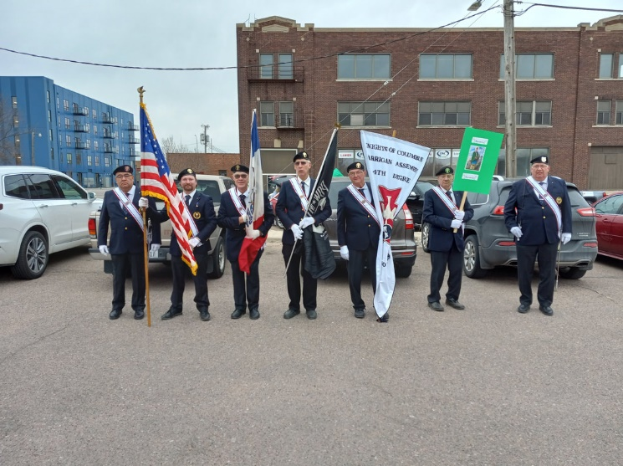
St. Patrick’s Day Parade on March 17th 2022

