FAITHFULL FRIAR REPORT
God is the creator and Ruler of universe. He alone is independent because He alone exists of Himself. All other things have received existence from Him and thus are dependent upon Him.
God is eternal. He always existed. He always has been and always will be.
God is a pure spirit, a sovereign intelligence who has no body and who cannot be perceived by our sense. Present everywhere, He can penetrate our most secret thoughts; all-powerful, He can do all things. He governs by His Love, His Mercy, and His Justice and nothing comes about without His command or without His permission. God is infinitely good, infinitely holy; infinitely just; in a word, He is infinitely perfect: He possesses without restriction or measure all perfections
Please keep the following in your prayers
Father Paul Albenesius, Father Dennis Meinen, Father Thomas Topf, Father Paul Bormann, Bishop R.Wallker Nickless, Sister Jean Marie, Doris Ott, Rick Davis, Mark Nixa, Sandy Bokemper, Gene Waag Sharon Seuntjens, Mike Boggs, Steve Cogdill Jr. Patricia LeClair, Marcia Goeden, Robert Goeden , Larry Kastrup, Valentin Magana, Ed Womack, Ann Womack, Julie Riedy, Jean Butler, Jack Garthright. Roxanne Winterfield, Jerry Reinert, Tammy Pasker, Jerome Puhl , Bob Kenaley, Hilda Luna, Jim Coy, Dennis Todd, Ronald Lansink, Lyle Spieler, Michael Peters, Larry Harrington, Jesse Padilla, Arden Gale, Manuel Luna, Bob Duncan, Francis Palmershiem, Doug Peters, Terri Mareau, John Voeltz, Gene Rolfes, Fred McPherson, Charles Myers, Chris Utesch,, Orlando Gill, Gary Engel, Don Roger, Denice Peters, Marilyn Laing, John Green, Robert Red Owl, Ricardo Rocha, Keaton Harvey, Persecuted Clergy and any others we may have missed.
A Prayer for Healing
Heavenly Father, ever caring, ever strong, stand by our family and friends in their time of need. We lift up our prayers especially for (Names)who are facing health issues and illnesses today. Look after them and grant them healing and peace. Give them hope and courage as they continue to go through difficult days. Comfort their pain, calm their fears and surround them with your peace and love. We sincerely pray also for others who are going through difficult days with their health care issues. We ask you bring healing, comfort and peace into their bodies. Fill them with your restorative spirit so they experience the healing power of your love. Lord Almighty God continue your blessings for the doctors and healthcare workers. Enlighten and guide them as they care for those who are also struggling with healthcare issues. Lend them your healing touch and use them as instruments for those recovering from illness.
In Jesus name, Amen

Knights of Columbus Fourth Degree
Garrigan Assembly
525 S. Irene St.
Sioux City, IA 51106
KC265Garrigan.weebly.com

August 2023

OFFICERS
Faithful Friar Rev. Dennis W. Meinen 712-258-9120
Faithful Navigator Jim Sanders 712-259-5399
Faithful Captain Michael Peters 712-259-6225
Faithful Pilot Ricardo Rocha 712-899-3700
Faithful Admiral Edward Womack 712-219-0374
Faithful Comptroller Marty Pasker 712-276-3672
Faithful Scribe Mark Fachman 712-333-2760
Faithful Purser John Staiert 712-898-9891
Faithful Inner Sentinel David Butler 712-823-8687
Faithful Outer Sentinel Michael Hays 605-740-6648
Faithful 1 yr. Trustee Stan Rolfes 712-568-3492
Faithful 2 yr. Trustee Donnis Rogers 712-239 4529
Faithful 3yr. Trustee Donald Davis 712-216-0415
Faithful Chalice Society Ricardo Rocha 712-899-3700
Faithful Web Master Michael Peters 712-259-6225
UPCOMING MEETINGS

August 17, 2023 Regular Meeting at St. Patrick’s Parish Hall 3rd and Mill St Akron, IA
Social @ 6;15, Dinner @ 6:45 Meeting to follow
August 26 2023 4th Degree Exemplification at Sioux City St Michaels
September 15, 2023 Regular Meeting at Hawarden St Mary’s Parish Hall
Social @ 6;15, Dinner @ 6:45 Meeting to follow
October 19, 2023 Regular Meeting at Sioux City Sacred Heart Parish Hall
Social @ 6;15, Dinner @ 6:45 Meeting to follow

FAITHFUL NAVIGATORS REPORT

Has this been a hot and fast summer so far? Our Lord and Savior , Jesus Christ must have busy fall and winter lined up for us . It is shaping up for us that way, because we have confirmations throughout the Assembly area coming up. We also have a late August Color Guard event at the Sioux City Explorers baseball game. We will have Installation of Officers at the 4th Degree Exemplification Banquet on August 26
Let’s not to for get to sponsor 3rd Degree Knights into the 4th degree exemplification on August 26 at Sioux City St. Michaels Church. Please get your candidates enrolled soon so that their registration is completed smoothly. Impress upon your candidate that their spouse and family members are welcome to attend their Knighting ceremony.
Lastly, we need more Knights throughout our Assembly to actively participate in Color and Honor Guards events. Our limited number of active Knights in Color and Honor Guards causes us not to have a good representation at functions that we are expected to attend.
May God our Father bless and guide us greatly as w further our Catholic Christian faith throughout the world.
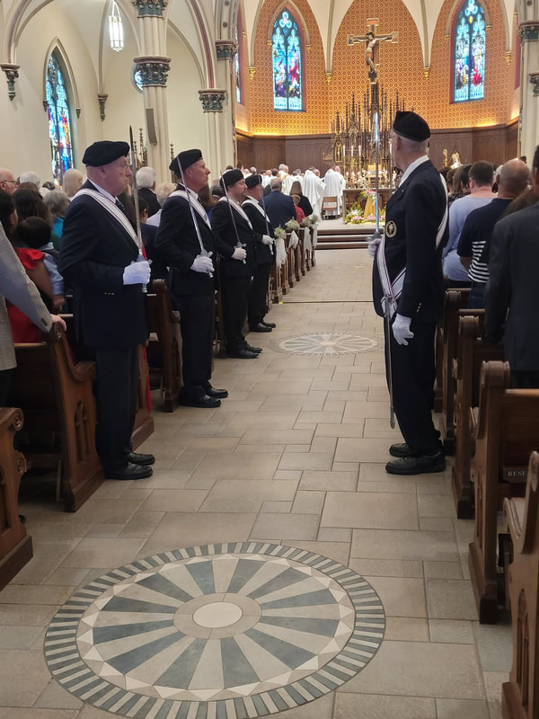

Faithful Pilots Report

No Honnor Guards for July

Color Guards Needed

August 24, 2023 Flar Raising at Sioux City Explorers Baseball Game
August 26, 2023 Fourt Degree Exemplification
October 1, 2023 Confirmation at Sioux City Nativity Parish. Be there 12:30 PM

.

