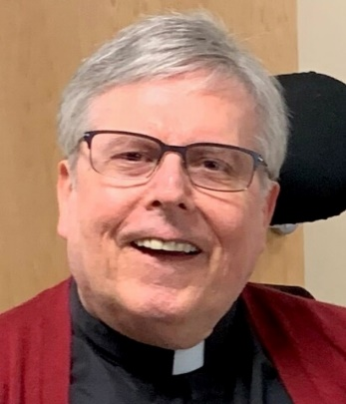

Father Dennis W. Meinen

February 6, 1951 — November 14, 2023

Dennis W. Meinen was born on February 6, 1951 in Sioux City, the son of Vincent and Rose (Gallagher) Meinen. He graduated from Bishop Heelan High School in 1969. He went on to serve in the United States Coast Guard for four years, from 1969-1973. He attended Briar Cliff College, and then went on to seminary at LaSalle Extension University and Sacred Heart School of Theology in Hales Corners, Wisconsin. He was ordained at St. Michael Catholic Church in Sioux City on May 29, 1987. His assignments over the years included: Parochial Vicar at Blessed Sacrament Parish from 1987-1990; Parochial Vicar at Immaculate Conception Parish from 1990-1993; Pastor at St. Boniface Parish in Charter Oak (also serving Ute) from 1993-1995; Pastor at St. Columbkille Parish in Churdan (also serving Cedar 1995-1996 and Scranton 1996-2000) from 1995-2000. He was Chaplain at Holy Spirit Retirement Home from 2003-2020.
Father Meinen was involved in many organizations across Siouxland, including: Chaplain of Scouting for the Sioux City Diocese; Faithful Friar of the Garrigan Assembly – Knights of Columbus; Columnist for the Lumen Catholic newspaper; was a member of the Calix society; and served on a committee on disabilities within the Sioux City Diocese. Father Meinen’s involvement was widespread within the community and was an example for those afflicted with disability.
Survivors include his brothers: Donald Meinen of Olathe, KS, Gene (Kay) Meinen of San Antonio, TX, and James Meinen of Tucson, AZ; nephews: Patrick Meinen of Virginia, and Michael Meinen of Texas; niece, Marie Fields of Florida; step-niece, Catherine Skelton of Missouri; and numerous cousins.
He was preceded in death by his parents; an infant brother, Gerald Anthony Meinen; and a sister-in-law, Cynthia Meinen.
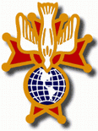
Knights of Columbus Fourth Degree
Garrigan Assembly
PO Box 515
Sergeant Bluff, IA 51054
KC265Garrigan.weebly.com

December 2023
OFFICERS
Faithful Friar Rev. Francis Makawinja 712-320-0723
Faithful Navigator Jim Sanders 712-259-5399
Faithful Captain Michael Peters 712-259-6225
Faithful Pilot Ricardo Rocha 712-899-3700
Faithful Admiral Edward Womack 712-219-0374
Faithful Comptroller Randy Kramer 712-251-5100
Faithful Scribe Mark Fachman 712-333-2760
Faithful Purser John Staiert 712-898-9891
Faithful Inner Sentinel Michael Koch 712-574-9334
Faithful Outer Sentinel Michael Hays 712-710-8825
Faithful 1 yr. Trustee Stan Rolfes 712-568-3492
Faithful 2 yr. Trustee Marty Pasker 712-276-3672
Faithful 3yr. Trustee Donald Davis 712-216-0415
Faithful Chalice Society Ricardo Rocha 712-899-3700
Faithful Web Master Michael Peters 712-259-6225
UPCOMING MEETINGS

7 December, 2023 Annual Garrigan Assembly Christmas Party at Grahms in Dakkota Dunes Cocktails at 5:30 Dinner at 6:00 PM

18 January, 2024 Regular Meeting South Sioux City Knights of Columbus Hall 1805 W 29th St South Sioux City NE. Social at 6:15 Dinner at 6:45 Meeting to follow.

15 February, 2024 Regular Meeting at Sioux City St. Michael’s Parish Hall 2223 Indian Hills Dr. . Social at 6:15 Dinner at 6:45 Meeting to follow.

FAITHFUL NAVIGATORS REPOR

It is with deep sadness the Garrigan Assembly of Fourth Degree Knights of
Columbus pays its final respects to the passing of our Faithful Friar, Fr. Dennis Meinen. Fr. Meinen was a dedicated faithful friar for our Assembly for many years. He endured many years of illness. Now he can rejoice in the arms of his Lord and Savior. Rest in peace Fr. Meinen.

Fr. Francis Makwinja has graciously agreed to serve as our new Faithful Friar. Let us all thank him for accepting this position in our Assembly.

Don’t forget our December 7th Christmas dinner at Graham’s in Dakota Dunes. Cocktails begin at 5:30 with dinner at 6. Please contact Michael Peters by December 1 for your reservations. Margaret and I look forward to seeing you.

Please keep the following in your prayers Father Paul Albenesius, Father Thomas Topf, Father Paul Bormann, Bishop R.Wallker Nickless, Father David Hemann, Sister Jean Marie, Doris Ott, Rick Davis, Mark Nixa, Sandy Bokemper, Gene Waag Sharon Seuntjens, Mike Boggs, Steve Cogdill Jr. Patricia LeClair, Marcia Goeden, Robert Goeden , Larry Kastrup, Valentin Magana, Ed Womack, Ann Womack, Julie Riedy, Jean Butler, Jack Garthright. Roxanne Winterfield, Tammy Pasker, Jerome Puhl , Bob Kenaley, Hilda Luna, Jim Coy, Dennis Todd, Ronald Lansink, Lyle Spieler, Larry Harrington, Jesse Padilla, Arden Gale, Manuel Luna, Bob Duncan, Francis Palmershiem, Doug Peters, Terri Mareau, John Voeltz, Gene Rolfes, Fred McPherson, Charles Myers, Chris Utesch,, Orlando Gill, Gary Engel, Don Roger, Marilyn Laing, John Green, Robert Red Owl, Ricardo Rocha, Dennis Fredricksen, Terry Clarey, Marci Hoffman, James Geary Jr. Kevin Sopha, Persecuted Clergy and any others we may have missed.

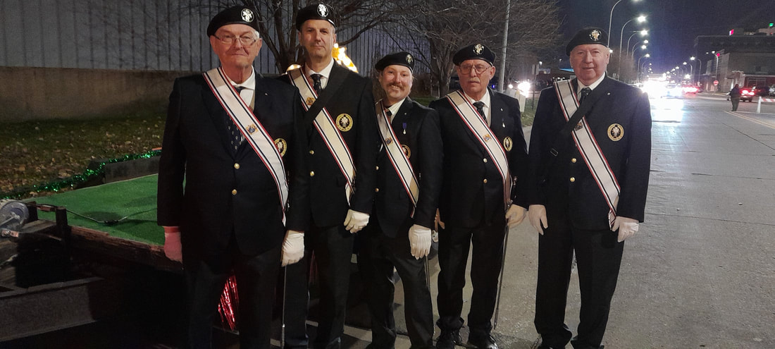
November 20th, 2023 Color Guard Event HOLIDAY LIGHTED PARADE DOWNTOWN SIOUX CITY,IA

FAITHFUL PILOTS REPORT
November Honor Guards
5 November, 2023 Confirmation Sioux City St Michaels:
Michael Peters, Michael Hays, Michael Koch, Ricardo Rocha,
David Butler
6 November 2023 Red Mass at Sioxu City Cathedral:
Michael Peters, Michael Hays, Michael Koch, Ricardo Rocha,
Jim Sanders
9 November, 2023 25th Rededication of Sioux City Cathedral:
Michael Peters, Michael Hays, Michael Koch, Ricardo Rocha,
Jim Sanders
12 November, 2023 Memorial Mass Sioux City St Michaels:
Michael Peters, Michael Hays, Marty Pasker, David Butler
Jjm Sanders
17 November, 2023 Wake Service for Father Meinen:
Jim Sanders, Michael Hays, Michael Gaspers, Michael Koch,
Ricardo Rocha, Steve Shults, George Hargens, Marty Pasker, Stan Rolfes, Jim coy, Bernard Alassouma, Dennis Kluver, John Staiert, Michael Peters
18 November 2023 Father Meinen Funeral Mass:
Jim Sanders, Michael Hays, Michael Gaspers, Michael Koch, Michael Peters, Steve Shults, Ricardo Rocha, Marty Pasker, Jerry Collins, Jim Coy, Bernard Alassouma, Dennis Kluver, John Hildman
19 November 2023 Confirmation Sioux City St. Michaels:
Michael Peters, Michael Hays, Jim Sanders, Ricardo Rocha, Bernard Alassouma
20 November, 2023 Sioux City Holiday Lighted Parade:
Michael Peters, Michael Koch, Michael Hays, Ricardo Rocha,
John Hildman, George Hargens, Jim Sanders, Marty Pasker

