A PRAYER FOR GUIDANCE
Lord, God Almighty, you have brought us safely to the beginning of this day. Defend us today by your mighty power, that we may not fall into any sin, but that all our words may so proceed and all our thoughts and actions be so directed, as to be always just in your sight. Through Christ our Lord. Amen.
Direct, we beg you, O Lord, our actions by your holy inspirations, and carry them on by your gracious assistance, that every prayer and work of ours may begin always with you, and through you be happily ended.

Please keep the following in your prayers Father Paul Albenesius, Father Dennis Meinen, Father Thomas Topf, Father Paul Bormann, Bishop R.Wallker Nickless, Sister Jean Marie, Doris Ott, Rick Davis, Mark Nixa, Sandy Bokemper, Gene Waag Sharon Seuntjens, Mike Boggs, Barb Cogdill, Steve Cogdill Jr. Patricia LeClair, Marcia Goeden, Robert Goeden , Larry Kastrup, Valentin Magana, Ed Womack, Ann Womack, Julie Riedy, Jean Butler, Jack Garthright. Roxanne Winterfield, Jerry Reinert, Tammy Pasker, Jerome Puhl , Bob Kenaley, Ruth Kenaley, Hilda Luna, Jim Coy, Dennis Todd, Ronald Lansink, Lyle Spieler, Michael Peters, Larry Harrington, Jesse Padilla, Arden Gale, Manuel Luna, Bob Duncan, Tom Huls, Francis Palmershiem, Doug Peters, Terri Mareau, John Voeltz, Mark Fachman, Gene Rolfes, Alvina Harvey, Fred McPherson, Charles Myers, Chris Utesch, Terrance Clarey, Orlando Gill, Gary Engel, Don Roger, Jim Henrich, Persecuted Clergy and any others we may have missed.
A Prayer for Healing
Heavenly Father, ever caring, ever strong, stand by our family and friends in their time of need. We lift up our prayers especially for (Names)who are facing health issues and illnesses today. Look after them and grant them healing and peace. Give them hope and courage as they continue to go through difficult days. Comfort their pain, calm their fears and surround them with your peace and love. We sincerely pray also for others who are going through difficult days with their health care issues. We ask you bring healing, comfort and peace into their bodies. Fill them with your restorative spirit so they experience the healing power of your love. Lord Almighty God continue your blessings for the doctors and healthcare workers. Enlighten and guide them as they care for those who are also struggling with healthcare issues. Lend them your healing touch and use them as instruments for those recovering from illness.
In Jesus name, Amen

Knights of Columbus Fourth Degree
Garrigan Assembly
525 S. Irene St.
Sioux City, IA 51106
KC265Garrigan.weebly.com

February 2023
OFFICERS
Faithful Friar Rev. Dennis W. Meinen 712-258-9120
Faithful Navigator Jim Sanders 712-259-5399
Faithful Captain Michael Peters 712-259-6225
Faithful Pilot Ricardo Rocha 712-899-3700
Faithful Admiral Edward Womack 712-219-0374
Faithful Comptroller Marty Pasker 712-276-3672
Faithful Scribe Mark Fachman 712-333-2760
Faithful Purser John Staiert 712-898-9891
Faithful Inner Sentinel David Butler 712-823-8687
Faithful Outer Sentinel Michael Hays 605-740-6648
Faithful 1 yr. Trustee Stan Rolfes 712-568-3492
Faithful 2 yr. Trustee Donnis Rogers 712-239 4529
Faithful 3yr. Trustee Donald Davis 712-216-0415
Faithful Chalice Society Ricardo Rocha 712-899-3700
Faithful Web Master Michael Peters 712-259-6225
UP COMING MEETINGS
February 16, 2023 Sioux City St Michaels 2222 Indian Hills Dr.
Social @ 6;15, Dinner @ 6:45 Meeting to follow
March 16,2023 Mapleton
Social @ 6;15, Dinner @ 6:45 Meeting to follow
April 20, 2023 St. John Parish Onawa

Faithful Navigator Comments
As we approach this Lenten season, I am reminded of the three pillars our Catholic faith focuses around…Prayer, Fasting and Almsgiving during Lent. A question that often comes to mind for many is, “How do we strive to attain these pillars consistently during Lent?”
Allow me to offer some suggestions.
1. We can commit to more quiet time for devotion.
2. Pray more often daily.
3. Memorize a verse or passage from the Bible meaningful to you.
4. Start a Bible Reading plan.
5. Study Jesus.
6. Limit mass and social media exposure.
7. Simplify food intake.
8. Fast more often.
9. Be more generous to our needy.
May our Lord bless us greatly as we prepare for our Lenten journey.

Lastly, do not forget to bring your spouse to our meeting at St Michaels on February 16. In addition to our dinner and meeting, we have a program planned for them titled “ Sweet like Honey”, a very enjoyable presentation.

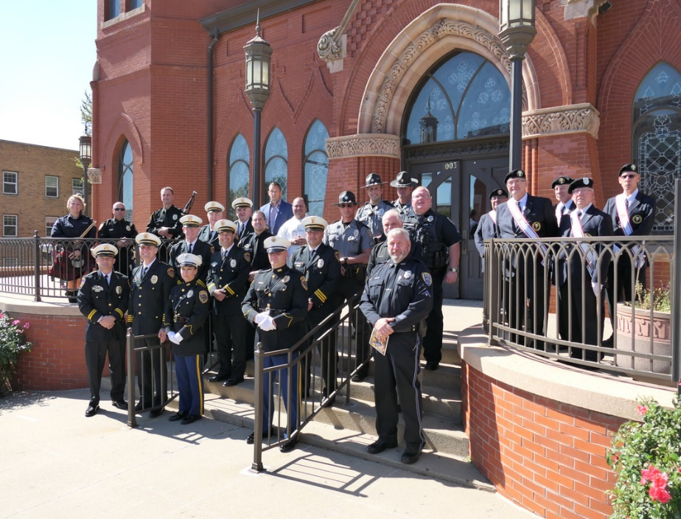
Outside the Cathedral

Faithful Pilots Report

NO REPORT

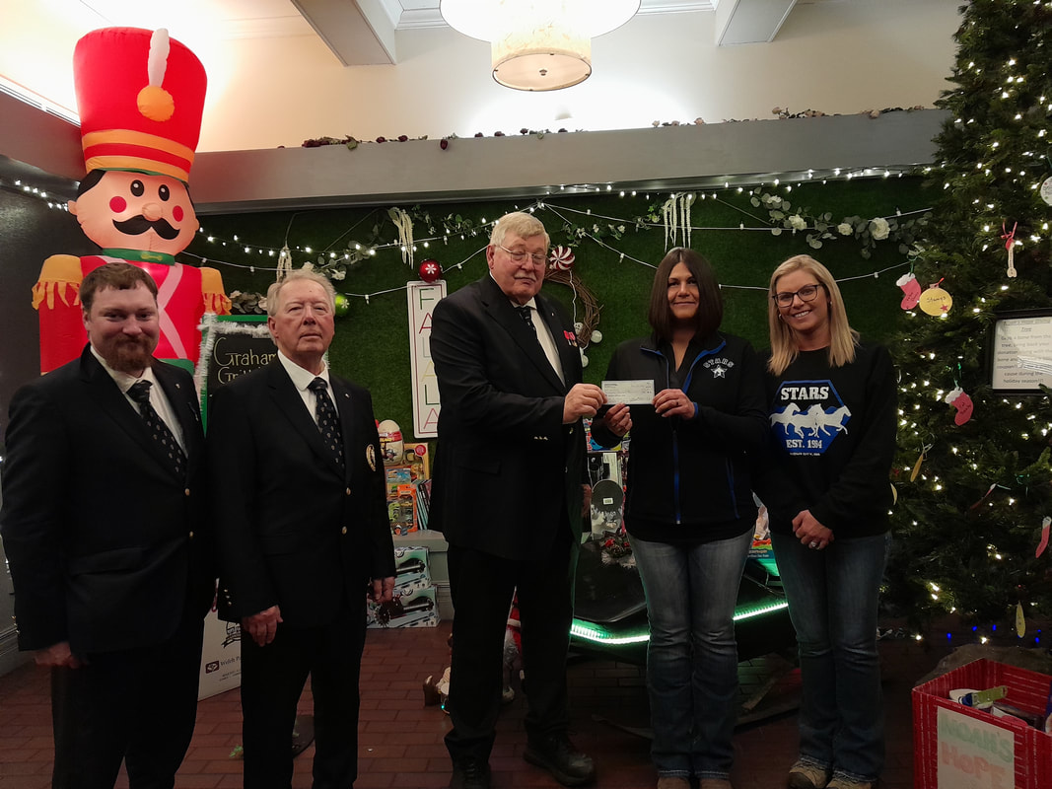
DECEMBER 15TH, 2022 The donation of the 50/50 raffle fund to Special Troopers Adaptive Riding School ( S.T.A.R.S. ) This was at our annual 4th Degree Christmas party.

