FAITHFULL FRIAR REPORT
Prayer to Mary, Patroness to the United States
Most Holy Trinity, Our Father in Heaven, who chose Mary as the fairest of your daughters; Holy spirit, who chose Mary as your spouse; God the Son, who chose Mary as your Mother, in union with Mary we adore your majesty and acknowledge your supreme, eternal domination and authority.
Most Holy Trinity, we put the United States of America into the hands of Mary Immaculate in order that she may present the country to you. Though you, we wish to thank you for the great resources of this land and for the freedom which has been its heritage.
Through the intercession of Mary, have mercy o the Catholic Church in America. Grant us peace. Have mercy on our president and on all of the officers of our government. Grant us a fruitful economy, born of justice and charity.
Have mercy on capital and industry and labor. Protect the family life of the nation. Guard the precious gift of many religious vocations. Through the intercession of our Mother, have mercy on the sick, the tempted, sinners, and all who are in need.
Mary, Immaculate Virgin, our Mother, Patroness of our land, we praise you and honor you and give ourselves to you. Protect us from every harm. Pray for us, that acting always according to your will and the will of your divine Son, we may live and die pleasing to God. Amen.
Please keep the following in your prayers
Father Paul Albenesius, Father Dennis Meinen, Father Thomas Topf, Father Paul Bormann, Bishop R.Wallker Nickless, Sister Jean Marie, Doris Ott, Rick Davis, Mark Nixa, Sandy Bokemper, Gene Waag Sharon Seuntjens, Mike Boggs, Steve Cogdill Jr. Patricia LeClair, Marcia Goeden, Robert Goeden , Larry Kastrup, Valentin Magana, Ed Womack, Ann Womack, Julie Riedy, Jean Butler, Jack Garthright. Roxanne Winterfield, Jerry Reinert, Tammy Pasker, Jerome Puhl , Bob Kenaley, Hilda Luna, Jim Coy, Dennis Todd, Ronald Lansink, Lyle Spieler, Michael Peters, Larry Harrington, Jesse Padilla, Arden Gale, Manuel Luna, Bob Duncan, Francis Palmershiem, Doug Peters, Terri Mareau, John Voeltz, Gene Rolfes, Alvina Harvey, Fred McPherson, Charles Myers, Chris Utesch, Terrance Clarey, Orlando Gill, Gary Engel, Don Roger, Denice Peters, Marilyn Laing, John Green, Robert Red Owl, Ricardo Rocha, Persecuted Clergy and any others we may have missed.
Prayer to God, The source of Health
God our Father, source of all health, be near those who suffer in time of weakness and pain: relieve them of their burden and heal them, if it be your will.
Give peaceful sleep to those who need rest for soul and body, and be with them in their hour of silence. Inspire with Your love those who bring healing and care to the suffering. May they bestow Your gift of health and strength wherever the go, Grant this prayer through Christ our Lord. Amen

Knights of Columbus Fourth Degree
Garrigan Assembly
525 S. Irene St.
Sioux City, IA 51106
KC265Garrigan.weebly.com

July 2023

OFFICERS
Faithful Friar Rev. Dennis W. Meinen 712-258-9120
Faithful Navigator Jim Sanders 712-259-5399
Faithful Captain Michael Peters 712-259-6225
Faithful Pilot Ricardo Rocha 712-899-3700
Faithful Admiral Edward Womack 712-219-0374
Faithful Comptroller Marty Pasker 712-276-3672
Faithful Scribe Mark Fachman 712-333-2760
Faithful Purser John Staiert 712-898-9891
Faithful Inner Sentinel David Butler 712-823-8687
Faithful Outer Sentinel Michael Hays 605-740-6648
Faithful 1 yr. Trustee Stan Rolfes 712-568-3492
Faithful 2 yr. Trustee Donnis Rogers 712-239 4529
Faithful 3yr. Trustee Donald Davis 712-216-0415
Faithful Chalice Society Ricardo Rocha 712-899-3700
Faithful Web Master Michael Peters 712-259-6225
UPCOMING MEETINGS
July 20, 2023 Regular Meeting Sioux City Immaculate Conception Parish Hall 1212 Morningside Ave
Mass at 5:30
Installation of Officers following Mass
Social,, Dinner, Meeting to follow

August 17, 2023 Regular Meeting at St. Patrick’s Parish Hall 3rd and Mill St Akron, IA
Social @ 6;15, Dinner @ 6:45 Meeting to follow

Faithful Navigator Comments
At our June meeting in Ida Grove, the following Sir Knights were elected by unanimous ballot to the following positions:
Faithful Comptroller Randy Kramer
Faithful Inner Sentinel Michael Koch
Faithful 2 yr Trustee Marty Pasker

The following Officers will retain their positions for another year:
Faithful Navigator James Sanders
Faithful Captain Michael Peters
Faithful Purse John Staiert
Faithful Scribe Mark Fachman
Faithful Pilot Ricardo Rocha
Faithful 1 Yr Trustee Stan Rolfes
Faithful 3 Yr. Trustee Donald Davis
Faithful Chalice Society RicardoRocha
Faithful Web Master Michael Peters

Our formal officer installation will be at our July 20th meeting at Immaculate Conception Church in Sioux City. We will begin with a 5:30pm Mass, followed by our installation ceremony. Cocktails will be served at 6:30 followed by a dinner. There will be no formal meeting following dinner. I encourage each of you and your spouses if possible to attend.
Place August 26, on your calendar. We need each Sir Knight to invite a 3rd degree knight to advance to the 4th degree at our Exemplification hosted by our Assembly at St. Michael’s Catholic Church in Sioux City. We need 30 or more new candidates to make this a successful Exemplification. I appreciate your support.
Lastly, we have 2 color guard events at Lewis and Clark Park for Explorer baseball games. Each game is preceded by a tailgate barbecue. All Sir Knights and families are welcome. Our August 17th meeting is scheduled at St. Patrick’s Hall, 3rd and Mill, Akron, Iowa. Bring your spouses for the dinner.
I want to thank Marty Pasker and Donnis Rogers for the for their commitment to Garrigan Assembly. Marty has been voted in to fill in the Two Year Trustee Position vacated by the departure of Donnis Rogers who is retiring to the Kansas City area. We wish Donnis great Happiness in retirement.
In closing, I pray for a safe summer season for all. May our Lord and Savior bless each of us greatly as we perform our patriotic duties to Him and his followers. Thank you all for your dedication to our Faith and Nation.
May our Lord and Savior bless each of us as we go forward.

Faithful Pilots Report

June 3, 2023 Priest Ordination at Cathedral of Epiphany:
Michel Peters, Michael Koch, Michael Hays, Jim Sanders,
Ricardo Rocha, David Butler, John Hilldman III, Jerry Collins
June 8, 2023 Flag Raising at Sioux City Explorers Baseball Game :
Michael Gaspers, Michael Hays, Michael Koch, Jim Sanders,
Ricardo Rocha
June 11, 2023 Corpus Christi Procession at Cathedral of Epiphany:
David Butler, Michael Hays
June 11, 2023 Corpus Christi Procession at Sioux City Holy Cross:
Michael Koch, Michael Peters, Bernard Allassouma
June 11, 2023 Corpus Christi Procession at Sioux City Mater Dei:
Ricardo Rocha, Jim Sanders, John HildmanIII, John Staiert
June 13, 2023 Funeral Mass for Philip Vondrak:
Ricardo Rocha, Marty Pasker, Michael Hays, Michael Koch, Michael Peters, Bernard Allassouma, David Butler
Color Guards Needed
August 3, 2023 Flag raising at Sioux City Explorers Baseball Game
Be there 6:30
August 24, 2023 Flag raising at Sioux City Explorers Baseball Be there at 6:30 PM
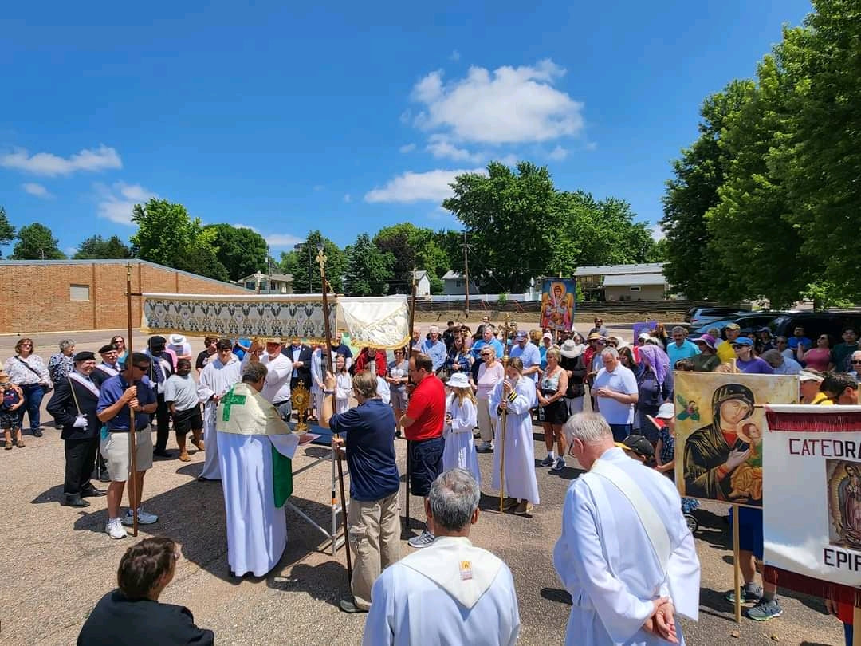

June 11, 2023 Corpus Christi Mass and Procession at S.C Holy Cross

