FAITHFUL FRIAR REPORT
Prayer for Today’s Needs

Lord for tomorrow and it’s needs, I do not pray, Keep me my God, from stain of sin just for today.
Let me both diligently work and duly pray; let me be kind in word and deed, just for today.
Let be slow to do my will, prompt to obey; help me to mortify my flesh, just for today.
Let me no wrong or idle word unthinking say; set a seal upon my lips, just for today.
Let me in season, Lord, be grave, in season gay; let me be faithful to your grace, just for today.
And if today my tide of life should ebb away, give me your sacraments divine, sweet Lord today.
So for tomorrow and its needs, I do not pray: but keep me, guide me, love me Lord, Just for today

Please keep the following in your prayers
Father Patrick O’Kane, Father Paul Albenesius, Father Dennis Meinen,
Father Thomas Topf, Father Paul Bormann, Sister Jean Marie, Greg Horan, Doris Ott, Jim Geary, Rick Davis, Mark Nixa, Sandy Bokemper, Gene Waag Sharon Seuntjens, Mike Boggs, Barb Cogdill, Steve Cogdill Jr., Michael Monahan, Patricia LeClair, Dallas Wilken, Clarice Wilken, Marcia Goeden, Robert Goeden Dr. John Amdor Jr., Marvin Schmitt, Larry Kastrup, Emory Graftis, Valentin Magana, Ed Womack, Ann Womack, Julie Riedy, Jean Butler, Nancy Barker, Jack Garthright. Roxanne Winterfield , Jerry Reinert, Tammy Pasker, Jim Harvey, Jerome Puhl, . Bob Kenaley, Ruth Kenaley, Hilda Luna, Jim Coy, Sarah Fachman, Dennis Todd, Ronald Lansink, Shane Haire, Lyle Spieler, Michael Peters, Donnis Rogers, Larry Harrington, Jesse Padilla, Al Metz, Marty Pasker, Ruth Phelps, Persecuted Clergy and any others we may have missed.

Knights of Columbus Fourth Degree
Garrigan Assembly
525 S. Irene St.
Sioux City, IA 51106
KC265Garrigan.weebly.com

June 2021

OFFICERS
Faithful Friar Rev. Dennis W. Meinen 712-258-9120
Faithful Navigator Edward Womack 712-219-0374
Faithful Captain Iim Sanders 712-259-5399
Faithful Pilot Ricardo Rocha 712-899-3700
Faithful Admiral
Faithful Comptroller Marty Pasker 712-276-3672
Faithful Scribe
Faithful Purser
Faithful Inner Sentinel Gerald Reinert 712-258-5666
Faithful Outer Sentinel David Butler 712-823-8687
Faithful 1 yr. Trustee Stan Rolfes 712-551-6943
Faithful 2 yr. Trustee Donnis Rogers 712-239 4529
Faithful 3yr. Trustee Donald Davis 712-216-0415
Faithful Chalice Society William Fergen 712-253-7744
Faithful Web Master Michael Peters 712-259-6225
UPCOMING MEETINGS

17 June, 2021. Regular Meeting at Ida Grove Sacred Heart. Social at 6:15 with dinner at 6:45. Meeting to follow.
15 July, 2021 Regular Meeting at Sioux City Immaculate Conception, 1212 Morningside Ave: Social at 6:15 with Dinner at 6:45 Meeting to follow.
19 August 2021 Regular meeting at Holy Spirit Retirement Home

Faithful Navigator Comments

Due to the cost of Chalices and the task of placing them with a priest, a proposal was made that we keep track of all of the deaths for the current year and have all of the names engraved on one better chalice (rather than one name per chalice as is currently done). We will be discussing this some more at the June meeting in Ida Grove and will vote on the proposal in July. We would value your input on this matter so please attend the meetings if you can.

Nomination of Officers: All current officers will be nominated to remain in their current role except for the following changes.
Faithful Friar: We are still looking for a replacement for Father Meinen who has retired from his role.
Faithful Admiral: Stan Rolfes
Faithful Pursar: John Staiert
Faithful Scribe: Still need someone to replace Jim Bisenius who has moved
Faithful One Year trustee: Mike Koch
Faithful Chalice Society: Deacon Richard Port
A motion was made and seconded and passed to consider all nominated officers as voted in.

The Faithful Scribe would like to know whose E-Mail this is. (636568iahist@q.com) If it is an old address, please send your new address to either Marty Pasker or Ed Womack so the list can be up dated.

Faithful Pilots Report
Honor Guards
14 May, 2021 Francis Drev Wake Service: Ricardo Rocha, Pat Frediemann, Edward Womack, Roger Fineran, Ben Lachman, Matrin Pasker, Steve Shults, Allen Lansink, Joe Cronin, Raymond Drey, John Stairet, David Forbes, David Cronin, Tom Cooper, Michael Gaspers
18 May, 2021 Dedcation of St. John Paul II: Michael Koch
Faithful Pilots Report Continued
31 May, 2021 Memorial Day Mass at Calvary Cemetery: Jerry Reinert. Jim Coy, Ricardo Rocha, Michael Gaspers, Marty Pasker, David Butler, Steve Shults
3 June, 2021 Wake Service for Jim Hamilton:
Ricardo Rocha, Jim Coy, Michael Peters, Steve Shults, Martin Pasker, David Butler, John Staiert
4 June, 2021 Funeral Mass for Jime Hmailton:
Marty Pasker, Allen Lansink, Steve Shults, David Bultle
5 June, 2021 Ordination of Deacons: Michael Peters, Steve Scott, Jim Coy, Michael Koch, Mel Smith, Brian Jergens, Jim LsVelle, John ford, Dave Lansing, Don rogers, Steve Shults, John Staiert, Steven Becker, Kevin McKinney, Ricardo Rocha
6 June, 2021 Corpus Christy Mass and Procession at Mater Dei: Ricardo Rocha, John Staiert
6 June 2021 Corpus Christy Mass and Procession at Holy Cross: Mijchael cKokch, Michael Peters, Don Rogers, Bernard Allassouma, Michael Gaspers
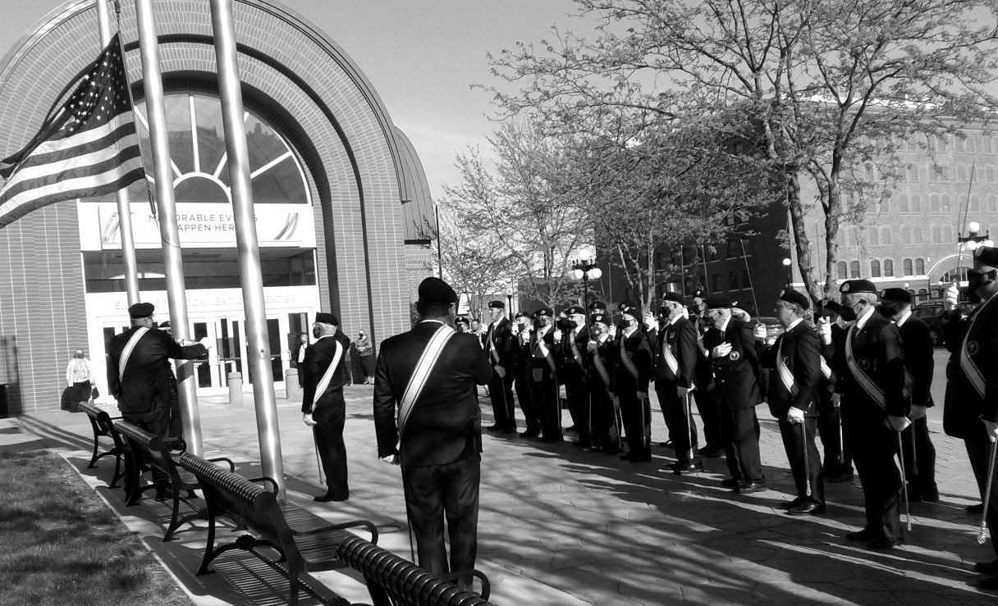
Honnor Guard at State Convention

