A PRAYER TO ST. PATRICK

Dear St. Patrick, in your humility you called yourself a sinner, but you became a most successful missionary and prompted countless pagans to follow the Savior. Many of their descendants in turn spread the Good News in numerous foreign lands. Through your powerful intercession with God, obtain for us sthe missionaries we need to continue the work you begun. Amen

Please keep the following in your prayers Father Paul Albenesius, Father Dennis Meinen, Father Thomas Topf, Father Paul Bormann, Bishop R.Wallker Nickless, Sister Jean Marie, Doris Ott, Rick Davis, Mark Nixa, Sandy Bokemper, Gene Waag Sharon Seuntjens, Mike Boggs, Barb Cogdill, Steve Cogdill Jr. Patricia LeClair, Marcia Goeden, Robert Goeden , Larry Kastrup, Valentin Magana, Ed Womack, Ann Womack, Julie Riedy, Jean Butler, Jack Garthright. Roxanne Winterfield, Jerry Reinert, Tammy Pasker, Jerome Puhl , Bob Kenaley, Hilda Luna, Jim Coy, Dennis Todd, Ronald Lansink, Lyle Spieler, Michael Peters, Larry Harrington, Jesse Padilla, Arden Gale, Manuel Luna, Bob Duncan, Francis Palmershiem, Doug Peters, Terri Mareau, John Voeltz, Gene Rolfes, Alvina Harvey, Fred McPherson, Charles Myers, Chris Utesch, Terrance Clarey, Orlando Gill, Gary Engel, Don Roger, Denice Peters, Marilyn Laing, Persecuted Clergy and any others we may have missed.
PRAYER FOR THE SICK

Ever abiding on, the sick need you in their lives more than ever. Each day brings its own set of challenges for their vulnerable spirit and body. Help them to live with the conditions of their illness without giving in to discouragement or despair.
Do not let the conditions and the unknowns drown out the voice of your tender presence. Guide the physicians to make good decisions. Give them the courage and wisdom to make their own good choices in treating this illness of theirs
Teach them to embrace the gift of each new day and to give thanks for those who help them through the ups and down of this process Constantly assure them that you will not forsake them. May you always be at their side their trusted guardian. Help them to walk the delicate path of hope and surrender. Amen

Knights of Columbus Fourth Degree
Garrigan Assembly
525 S. Irene St.
Sioux City, IA 51106
KC265Garrigan.weebly.com

March 2023
OFFICERS
Faithful Friar Rev. Dennis W. Meinen 712-258-9120
Faithful Navigator Jim Sanders 712-259-5399
Faithful Captain Michael Peters 712-259-6225
Faithful Pilot Ricardo Rocha 712-899-3700
Faithful Admiral Edward Womack 712-219-0374
Faithful Comptroller Marty Pasker 712-276-3672
Faithful Scribe Mark Fachman 712-333-2760
Faithful Purser John Staiert 712-898-9891
Faithful Inner Sentinel David Butler 712-823-8687
Faithful Outer Sentinel Michael Hays 605-740-6648
Faithful 1 yr. Trustee Stan Rolfes 712-568-3492
Faithful 2 yr. Trustee Donnis Rogers 712-239 4529
Faithful 3yr. Trustee Donald Davis 712-216-0415
Faithful Chalice Society Ricardo Rocha 712-899-3700
Faithful Web Master Michael Peters 712-259-6225
UP COMING MEETINGS
March 16,2023 Mapleton St. Mary’s Parish Hall
Social @ 6;15, Dinner @ 6:45 Meeting to follow
Ca r Pool at Sam’s Club 5:00 PM
April 20, 2023 St. John Parish Onawa, Iowa
Social @ 6;15, Dinner @ 6:45 Meeting to follow
Car Pool at Sam’s Club at 5:00 PM
May 18, 2023 Salix
Social @ 6;15, Dinner @ 6:45 Meeting to follow

Faithful Navigator Comments
Recently I read a small booklet sponsored by my home parish, Mater Dei of Sioux City titled “Holy Moments “. I was amazed at how small or seemingly insignificant one of these moments can be. Most often they occur instantaneously, literally out of the blue. I’m sure many of you, if not all of you have experienced “holy moments” at several times in your life.

This week after a doctor’s appointment, I stopped at a convenience store in Sioux City to gas up my vehicle and get a slice of breakfast pizza. As I exited my vehicle, a young man approached me and mumbled something to the effect he was hungry. I quickly glanced him over, determining he was probably homeless and was indeed hungry. I told him to come inside with me, but he declined and said, “I am not allowed to enter “. I told him to wait and I would be out shortly. So I purchased 2 slices of pizza and left the store. He was waiting for me and I gave him one of the slices. He thanked me and quickly vanished from the premises. I recalled a similar incident in the booklet “Holy Moments “. They just happen. Cherish your holy moments whenever they happen. Let the Lord guide you when one interacts with you in your daily routine. May this Lenten season give all of us opportunities to experience “holy moments “ in our day-to-day activity.

Don’t forget to attend our meeting in Onawa March 16, and bring your spouse. An interesting program is scheduled for her while we conduct our business meeting. We will carpool from The Sam’s Club parking lot at 5:00 PM.

March 17, St. Patrick’s Day, our Garrigan Assembly has a float for the parade in Sioux City. We assemble at 5:30pm. We need as many Sir Knights possible for the color guard and the float to March and participate. See you there.

Do you have a milestone coming up in your life (80thor 90th birthday, Wedding anniversary etc) let me know at 712-551-6943 or slr1964 @premieronline.net. I will try an enter it into the Newsletter if room is available.

Faithful Pilots Report

No Color Guards held in February

Color Guards Needed
March 17, 2023 St Patrick’s Day Parade Meet at 3rd and Iowa Street at 5:30 PM
April 16, 2023 Divine Mercy Sunday at St Michael’s Church 2222 Indian Hills Dr. Be there at 10:30 AM
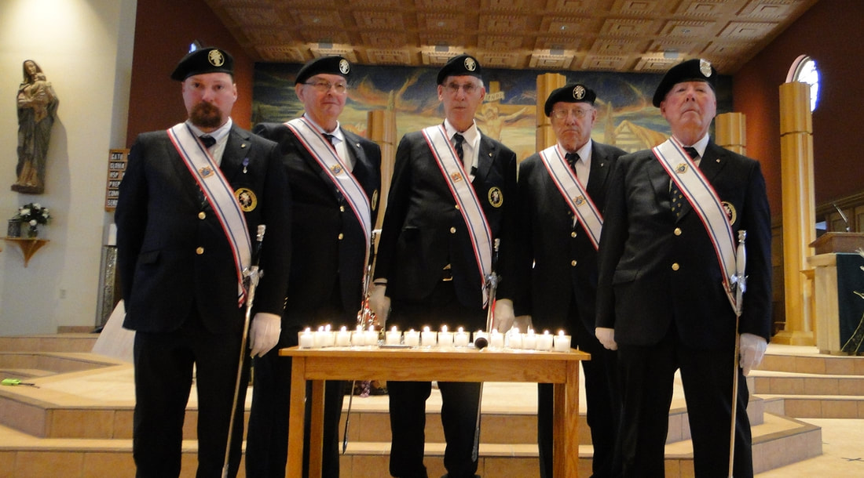

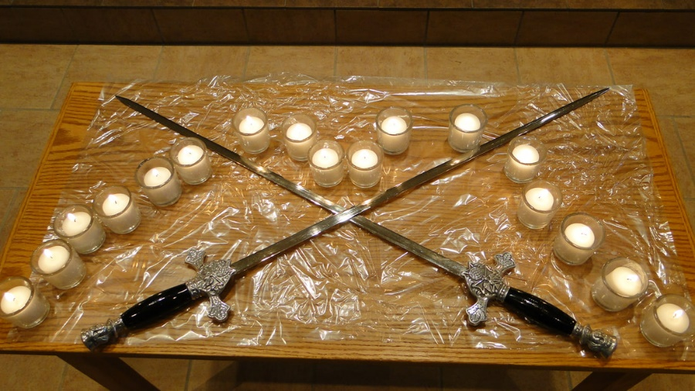
Memorial Mass November 2022

