FAITHFUL FRIAR’S REPORT
Jesus Christ came upon earth to destroy the reign of sin. He fought sin by His example, prophecies, and miracles; but above all He triumphed over sin by the merits of His passion and death.
He delivered Himself up to the malice of His enemies; He allowed Himself to be condemned to cruel punishment and be crucified. He shed all His Blood while praying for his persecutors; taking the place of the guilty. He suffered and died for them. He made satisfaction for the sins of all human beings; for those who preceded Him as well as those following Him.
Jesus Christ did not suffer and die as God, for a Divine Nature can neither suffer or die. He died as Man; but as God, He has given infinite value to His suffering and death. He died for all human beings including those who did not take advantage of His saving merits. The day in which the Church is a in a special manner, commemorates the death of Jesus Christ, is called Good Friday.
The death of the Son of God made Man, offering his life on the cross as a sacrifice for the salvation of mankind is called the Mystery of the Redemption of the human race; a mystery of love in which God has united His mercy and justice, in pardoning sinful human beings in view of the sacrifice and merits of His innocent Son.
Immediately after the death of Jesus Christ, His body was placed in a tomb, He then descended into hell, that is the place of the dead, to free all the souls of the just , the Patriarchs, and Prophets, who were detained there awaiting the coming of the Messiah and the Redemption of the world.

Please keep the following in your prayers Father Paul Albenesius, Father Thomas Topf, Father Paul Bormann, Sister Jean Marie, Doris Ott, Rick Davis, Sandy Bokemper, Gene Waag Sharon Seuntjens, Mike Boggs, Steve Cogdill Jr. Patricia LeClair, Marcia Goeden, Robert Goeden , Larry Kastrup, Valentin Magana, Ed Womack, Ann Womack, Julie Riedy, Jean Butler, Jack Garthright. Roxanne Winterfield, Tammy Pasker, Jerome Puhl , Bob Kenaley, Jim Coy, Dennis Todd, Ronald Lansink, Lyle Spieler, Larry Harrington, Jesse Padilla, Arden Gale, Manuel Luna, Bob Duncan, Doug Peters, Terri Mareau, John Voeltz, Gene Rolfes, Fred McPherson, Charles Myers, Chris Utesch,, Orlando Gill, Gary Engel, Don Roger, Marilyn Laing, John Green, Robert Red Owl, Ricardo Rocha, Dennis Fredricksen, Terry Clarey, Marci Hoffman, James Geary Jr. Kevin Sopha , Al Metz, Persecuted Clergy and any others we may have missed.
Ever abiding on, the sick need you in their lives more than ever. Each day brings its own set of challenges for their vulnerable spirit and body. Help them to live with the conditions of their illness without giving in to discouragement or despair. Constantly assure them that you will not forsake them. May you always be at their side their trusted guardian. Help them to walk the delicate path of hope and surrender. Amen
Knights of Columbus Fourth Degree

Garrigan Assembly
PO Box 515
Sergeant Bluff, IA 51054
KC265Garrigan.weebly.com

March 2024
OFFICERS

Faithful Friar Rev. Francis Makawinja 712-320-0723
Faithful Navigator Jim Sanders 712-259-5399
Faithful Captain Michael Peters 712-259-6225
Faithful Pilot Ricardo Rocha 712-899-3700
Faithful Admiral Edward Womack 712-219-0374
Faithful Comptroller Randy Kramer 712-251-5100
Faithful Scribe Mark Fachman 712-333-2760
Faithful Purser John Staiert 712-898-9891
Faithful Inner Sentinel Michael Koch 712-574-9334
Faithful Outer Sentinel Michael Hays 712-710-8825
Faithful 1 yr. Trustee Stan Rolfes 712-568-3492
Faithful 2 yr. Trustee Marty Pasker 712-276-3672
Faithful 3yr. Trustee Donald Davis 712-216-0415
Faithful Chalice Society Ricardo Rocha 712-899-3700
Faithful Web Master Michael Peters 712-259-6225

UPCOMING MEETINGS

21 March 2024 Regular Meeting at St Mary’s Parish Hall Mapleton, IA
Social at 6:15 Dinner at 6:45 Meeting to follow

18 April, 2024 Regular Meting St. John’s Parish Hall, Onawa, IA.
Social at 6:15 Dinner at 6:45 Meeting to follow

16 May, 2024 Regular Meeting at Salix 510 Tipton St, Salix, IA
Social at 6:15 Dinner at 6:45 Meeting to follow

FAITHFUL NAVIGATOR’S REPORT

Sir Knights, I trust you are well and having a good spiritual Lenten season. May we all be blessed by our Lord as we prepare for the blessings of the Holy Spirit at Easter. I plan to attend as many Friday fish fry dinners as possible, and look forward to meeting many of you in person.
Sir Knight Bob Duncan just gave me the dates of our Color Guard appearances at Explorer games this year at Lewis and Clark Park. They are as follows: May 30, June 7, July 31 and August 22. We will have a tail gate picnic in the parking area outside the stadium on the left field side. Tail gating will begin at 5:15. Our Sir Knight brothers will again perform and National Anthem prior to the game, while our color corps will present the colors. This is a fun event for us and allows us and our families to enjoy an evening together at an Explorers baseball game. So, please put these dates on your calendar and plan for an enjoyable evening at the ballpark.
We have the State Knights of Columbus coming up April 12-14 at Council Bluffs. We currently are allocated 5 delegates for the 4th Degree portion. Please contact me if you can attend the convention and be a delegate. The exemplification will be Friday afternoon for new candidates to join the 4th Degree. Please get your candidates application in as soon as possible. Feel free to contact me for any assistance.
As always, may our Lord’s love and kindness continue to bless and nourish each of us as we complete our mission as Knights of Columbus in the service of our Lord and Savior Jesus Christ.

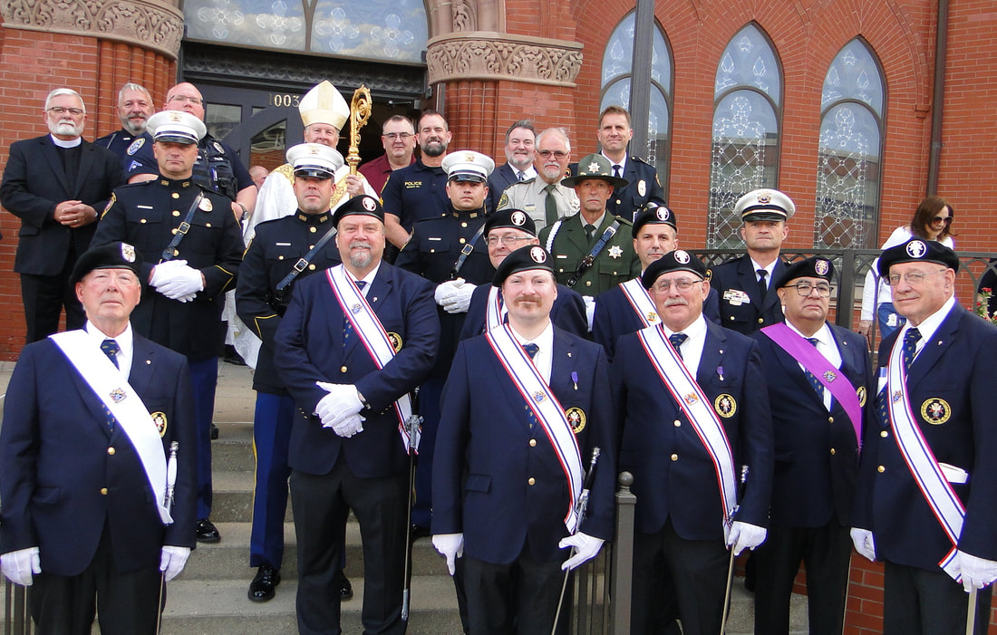

FAITHFUL PILOT’S REPORT

No Faithful Pilots Report this month

Up Coming Honor Guards Needed

17 March 2024 St Patrick’s Day Parade.
Meet at 2:00 pm at 3rd and Iowa St in Sioux City

7 April, 2024 Color Guard needed:
Divine Mercy Sunday at Sioux City St Michael Church2223 Indian Hills Dr.
Be there at 1:00 PM

20 April2024 Color Guard needed:
Confirmation at Sioux City St Miachel Church 2223 Indian Hills Dr.
Be there at 4:00PM

