FAITHFUL FRIAR REPORT
Prayer for Today’s Needs

Lord for tomorrow and it’s needs, I do not pray, Keep me my God, from stain of sin just for today.
Let me both diligently work and duly pray; let me be kind in word and deed, just for today.
Let be slow to do my will, prompt to obey; help me to mortify my flesh, just for today.
Let me no wrong or idle word unthinking say; set a seal upon my lips, just for today.
Let me in season, Lord, be grave, in season gay; let me be faithful to your grace, just for today.
And if today my tide of life should ebb away, give me your sacraments divine, sweet Lord today.
So for tomorrow and its needs, I do not pray: but keep me , guide me, love me Lord, Just for today

Please keep the following in your prayers
Father Patrick O’Kane, Father Paul Albenesius, Father Dennis Meinen,
Father Thomas Topf, Father Paul Bormann,Father Peter Duc Hung Nguyen, Sister Jean Marie, Greg Horan, Doris Ott, Jim Geary, Rick Davis, Mark Nixa, Sandy Bokemper, Gene Waag Sharon Seuntjens, Mike Boggs, Barb Cogdill, Steve Cogdill Jr., Michael Monahan, Patricia LeClair, Dallas Wilken, Clarice Wilken, Marcia Goeden, Robert Goeden Dr. John Amdor Jr., Marvin Schmitt, Larry Kastrup, Emory Graftis, Valentin Magana, Ed Womack, Ann Womack, Julie Riedy, Jean Butler, Nancy Barker, Jack Garthright. Roxanne Winterfield, , Jerry Reinert, Tammy Pasker, Jim Harvey, Jerome Puhl, . Bob Kenaley, Ruth Kenaley, Hilda Luna, Jim Coy, Sarah Fachman, Dennis Todd, Ronald Lansink, Shane Haire, Lyle Spieler, Michael Peters, Donnis Rogers, Larrington, Jesse Padilla, Al Metz,Marty Pasker, Ruth Phelps. Persecuted Clergy and any others we may have missed.

Knights of Columbus Fourth Degree
Garrigan Assembly
525 S. Irene St.
Sioux City, IA 51106
KC265Garrigan.weebly.com

May 2021

OFFICERS
Faithful Friar Rev. Dennis W. Meinen 712-258-9120
Faithful Navigator Edward Womack 712-219-0374
Faithful Captain Iim Sanders 712-259-5399
Faithful Pilot Ricardo Rocha 712-899-3700
Faithful Admiral
Faithful Comptroller Marty Pasker 712-276-3672
Faithful Scribe
Faithful Purser
Faithful Inner Sentinel Gerald Reinert 712-258-5666
Faithful Outer Sentinel David Butler 712-823-8687
Faithful 1 yr. Trustee Stan Rolfes 712-551-6943
Faithful 2 yr. Trustee Donnis Rogers 712-239 4529
Faithful 3yr. Trustee Donald Davis 712-216-0415
Faithful Chalice Society William Fergen 712-253-7744
Faithful Web Master Michael Peters 712-259-6225
UPCOMING MEETINGS

May 20, 2021 Regular Meeting of Garrigan Assembly at Sioux City Blessed Sacrament @ 7:00PM.

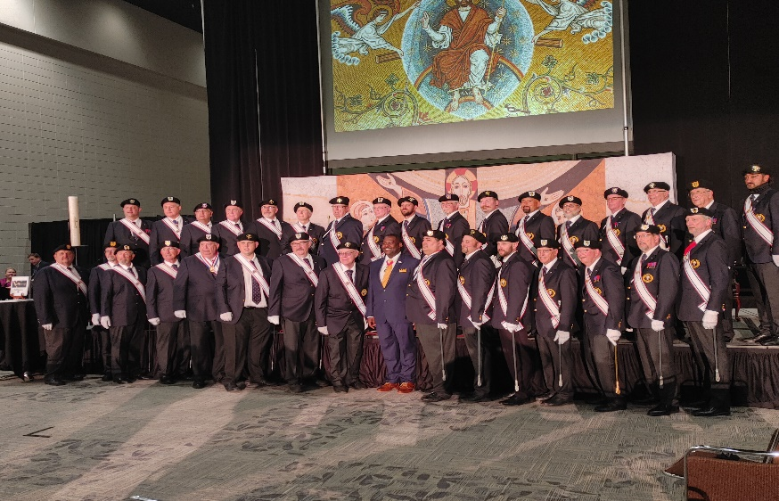
Hi Brother Knights
We had a great State Convention.
I wanted to thank everyone who worked it and took part in the Honor Guard and Color Guard. I had a great time.

It is time to vote again for officers, so think ahead who might be able to feel the open positions and any other position that might coming up. May God bless you all and thank all for what you do for the Assembly. I couldn't be more proud of it.
Thank you.

Eddie Womack

Faithful Pilots Report

No report from Faithful Pilot

