FAITHFULL FRIAR REPORT

Prayer to bring Christ into our day
Lord Jesus, present before me in the Sacrament of the Altar, help me to cast out from my mind all thoughts of which You do not approve and from my heart all emotions which You do not encourage. Enable me to spend my entire day with you, carrying out the task that You have entrusted to me. Be with me at every moment of this day: during the long hours of work, that I may never tire or slacken from Your service; during my conversations, that they may not become for me occasions for meanness toward others; during the moments of worry and stress , that I may remain patient and spiritually calm; during periods of fatigue and illness, , that I may avoid self-pity and think of others; during times of temptation , that I may take refuge in Your grace. Help me to remain generous and loyal to You this day and so be able to offer it all up to You with its successes which I have achieved by Your help and its failures which have occurred through my own fault. Le me come to the wonderful realization that life is most real when it is lived with You as the Guest of my soul.

Please keep the following in your prayers
Father Paul Albenesius, Father Dennis Meinen, Father Thomas Topf, Father Paul Bormann, Bishop R.Wallker Nickless, Sister Jean Marie, Doris Ott, Rick Davis, Mark Nixa, Sandy Bokemper, Gene Waag Sharon Seuntjens, Mike Boggs, Steve Cogdill Jr. Patricia LeClair, Marcia Goeden, Robert Goeden , Larry Kastrup, Valentin Magana, Ed Womack, Ann Womack, Julie Riedy, Jean Butler, Jack Garthright. Roxanne Winterfield, Jerry Reinert, Tammy Pasker, Jerome Puhl , Bob Kenaley, Hilda Luna, Jim Coy, Dennis Todd, Ronald Lansink, Lyle Spieler, Michael Peters, Larry Harrington, Jesse Padilla, Arden Gale, Manuel Luna, Bob Duncan, Francis Palmershiem, Doug Peters, Terri Mareau, John Voeltz, Gene Rolfes, Alvina Harvey, Fred McPherson, Charles Myers, Chris Utesch, Terrance Clarey, Orlando Gill, Gary Engel, Don Roger, Denice Peters, Marilyn Laing, Persecuted Clergy and any others we may have missed.

Prayer to God, The source of Health
God our Father, source of all health, be near those who suffer in time of weakness and pain: relieve them of their burden and heal them, if it be your will.
Give peaceful sleep to those who need rest for soul and body, and be with them in their hour of silence. Inspire with Your love those who bring healing and care to the suffering. May they bestow Your gift of health and strength wherever the go, Grant this prayer through Christ our Lord. Amen

Knights of Columbus Fourth Degree
Garrigan Assembly
525 S. Irene St.
Sioux City, IA 51106
KC265Garrigan.weebly.com

May 2023
OFFICERS
Faithful Friar Rev. Dennis W. Meinen 712-258-9120
Faithful Navigator Jim Sanders 712-259-5399
Faithful Captain Michael Peters 712-259-6225
Faithful Pilot Ricardo Rocha 712-899-3700
Faithful Admiral Edward Womack 712-219-0374
Faithful Comptroller Marty Pasker 712-276-3672
Faithful Scribe Mark Fachman 712-333-2760
Faithful Purser John Staiert 712-898-9891
Faithful Inner Sentinel David Butler 712-823-8687
Faithful Outer Sentinel Michael Hays 605-740-6648
Faithful 1 yr. Trustee Stan Rolfes 712-568-3492
Faithful 2 yr. Trustee Donnis Rogers 712-239 4529
Faithful 3yr. Trustee Donald Davis 712-216-0415
Faithful Chalice Society Ricardo Rocha 712-899-3700
Faithful Web Master Michael Peters 712-259-6225

UP COMING MEETINGS
May 18, 2023 Regular Meeting @ Sioux City Sacred Heart
Address is 5010 Military Rd. Sioux City, IA. Social @ 6;15, Dinner @ 6:45 Meeting to follow

June 15, 2023 Regular Meeting Sacred Heart Parish Hall Ida Grove, IA 800 N
Main St. Social @ 6;15, Dinner @ 6:45 Meeting to follow

July 12, 2023 Regular Meeting Sioux City Immaculate Conception Parish Hall 1212 Morningside Ave Social @ 6;15, Dinner @ 6:45 Meeting to follow

Faithful Navigator Comments
April left us rather quickly. Our recently completed state convention was a nice success. This year there was no formal meeting day for 4th degree members. However, our 4th degree Knights were very active throughout the convention, providing color guards at the two banquets. Sunday we had a 4th degree exemplification following the convention close. I believe 30 men became new members of the 4th degree. Congratulations gentlemen upon your entry into the 4th degree.

The Garrigan Assembly decided at our recent meeting in Onawa to sponsor a 4th degree Exemplification August 26, at St. Michael’s Catholic Church, Holy Cross Parish in Sioux City. Sir Knights this is a great way to increase our membership. It’s also a great challenge to each of us to actively contact and enroll men from our individual councils into the 4th degree. I firmly believe our Lord and Savior desires us individually and jointly to ensure this Exemplification a success by recruiting men from our Councils. We need good men of all ages to fill the ranks of those who have left us and carry on the mission of Christ’s purpose. May our Lord and Savior bless each of us greatly as we move forward and continue His mission.

A correction to last month’s newsletter, Our May meeting will be hosted by the Council at St Michael’s Church in Sioux City May 18. Please put this on your calendar. At this Assembly meeting we will accept nominations for any vacant office positions.

May the Spirit of our Lord and Savior bless each of us greatly, as we go forth completing His work
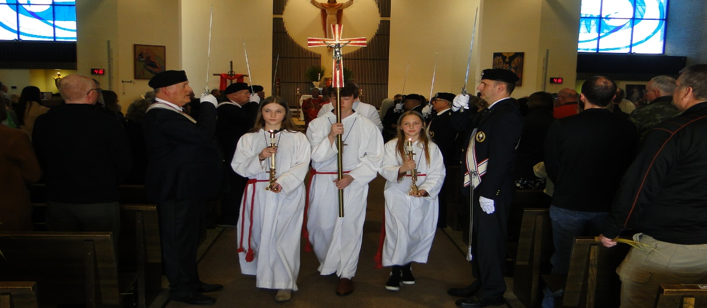

Faithful Pilots Report

1 April2023 Bread of Life Mass @ Sioux City Nativity
John Staiert, Roger Cramer, Michael Hays, John Hildman, Ricardo Rocha, Steve Shults
4 April, 2023 Divine Mercy Sunday @ Sioux City St.Michaels
Jim Coy, Michael Koch, Michael Hays, Michael Peters, Ricardo Rocha, Bernard Allassouma

Color Guards Needed
16 May, 2023 Flag Raising at Sioux City Explorers
Be there at 6:30
29 May, 2023 Memorial Day Mass at Sioux City Calvary Cemetery
Be there 8:30
June 11, 2023 Feast of Corpus Christi at Sioux City St. Michels Church. Be there at 10:30
June 8, 2023 Flag Raising at Sioux City Explorers Baseball Game
Be there 6:30.

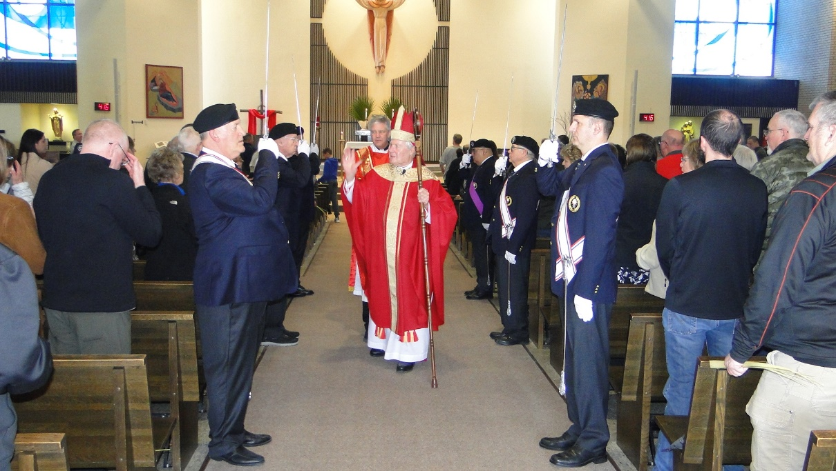
Palm Sunday @ Sioux City Nativity Parish

