FAITHFULL FRIAR REPORT
Among the creatures of God, the most perfect are Angels and men. The Angels are pure spirits created to adore God and execute his commandments. Many of these Angels revolted against their Creator, Who in turn, condemned them to hell. These Angels who we call demons or evil spirits hated God and tempt man on earth to defy the laws of God so as to be condemned to the same tortures that they themselves suffer.
The faithful Angels are confirmed in grace and have their abode in heaven for all eternity. We call some Guardian Angels because God has appointed them to keep watch over man on earth. Each one of us has a Guardian Angel

Please keep the following in your prayers
Father Paul Albenesius, Father Dennis Meinen, Father Thomas Topf, Father Paul Bormann, Bishop R.Wallker Nickless, Sister Jean Marie, Doris Ott, Rick Davis, Mark Nixa, Sandy Bokemper, Gene Waag Sharon Seuntjens, Mike Boggs, Steve Cogdill Jr. Patricia LeClair, Marcia Goeden, Robert Goeden , Larry Kastrup, Valentin Magana, Ed Womack, Ann Womack, Julie Riedy, Jean Butler, Jack Garthright. Roxanne Winterfield, Tammy Pasker, Jerome Puhl , Bob Kenaley, Hilda Luna, Jim Coy, Dennis Todd, Ronald Lansink, Lyle Spieler, Larry Harrington, Jesse Padilla, Arden Gale, Manuel Luna, Bob Duncan, Francis Palmershiem, Doug Peters, Terri Mareau, John Voeltz, Gene Rolfes, Fred McPherson, Charles Myers, Chris Utesch,, Orlando Gill, Gary Engel, Don Roger, Marilyn Laing, John Green, Robert Red Owl, Ricardo Rocha, Dennis Fredricksen, Clarice Wilken, Patricia Christensen, Terry Clarey, Persecuted Clergy and any others we may have missed.

PRAYER FOR THE SICK
Father God, we lift up all those who are facing illness today. We ask that you bring them healing, comfort and peace to their bodies. Calm their fears and let them experience the healing power of our love. In Jesus’ name Amen.

Knights of Columbus Fourth Degree
Garrigan Assembly
PO Box 515
Sergeant Bluff, IA 51054
KC265Garrigan.weebly.com

October 2023

OFFICERS
Faithful Friar Rev. Dennis W. Meinen 712-258-9120
Faithful Navigator Jim Sanders 712-259-5399
Faithful Captain Michael Peters 712-259-6225
Faithful Pilot Ricardo Rocha 712-899-3700
Faithful Admiral Edward Womack 712-219-0374
Faithful Comptroller Randy Kramer 712-251-5100
Faithful Scribe Mark Fachman 712-333-2760
Faithful Purser John Staiert 712-898-9891
Faithful Inner Sentinel Michael Koch 712-574-9334
Faithful Outer Sentinel Michael Hays 712-710-8825
Faithful 1 yr. Trustee Stan Rolfes 712-568-3492
Faithful 2 yr. Trustee Marty Pasker 712-276-3672
Faithful 3yr. Trustee Donald Davis 712-216-0415
Faithful Chalice Society Ricardo Rocha 712-899-3700
Faithful Web Master Michael Peters 712-259-6225

UPCOMING MEETINGS

October 19, 2023 Regular Meeting at Sioux City Sacred Heart Parish Hall
Social @ 6;15, Dinner @ 6:45 Meeting to follow
16 November 2023 Regular meeting at Sioux City Cathedral Social at 6:15, dinner at 6:45 Meeting to follow
7 December, 2023 Annual Garrigan Assembly Christmas Party at Grahms in Dakkota Dunes

FAITHFUL NAVIGATORS REPORT

The Confirmation season is upon us in our Sioux City Diocese. Our color corps/ honor guard has been busy. Serving in our color corps/ honor guard events is humbling, but rewarding experience. It adds a huge touch of pageantry to the event honoring not only our young people being confirmed, but displays our patriotic homage to our Lord and Savior, Jesus. I welcome all Sir Knights to consider joining the color corps/ honor guard. If you are concerned about the cost of the new style regalia, take advantage of our GULF program. The form can be downloaded from our website. The experiences from participating in color corps/ honor guard activities is immense.
Don’t forget to put December 7, 2023 on your calendar. This is the date of our Christmas dinner at Graham’s Restaurant in the Dunes. Please let Sir Knight Michael Peters, our Faithful Captain know of your intentions to attend by December 1st. During our dinner we will award a deserving charity a check from our 50/50 account proceeds.
We will have our Memorial service honoring deceased Knights of the past 12 months at St. Michaels Church November 12, following the 10 am Mass. I welcome the families of these fallen Knights to attend this solemn ceremony.
Lastly, I wish each of you a blessed fall for you and your families. May our Lord and Savior bless each of you as you express your faith in Him daily.

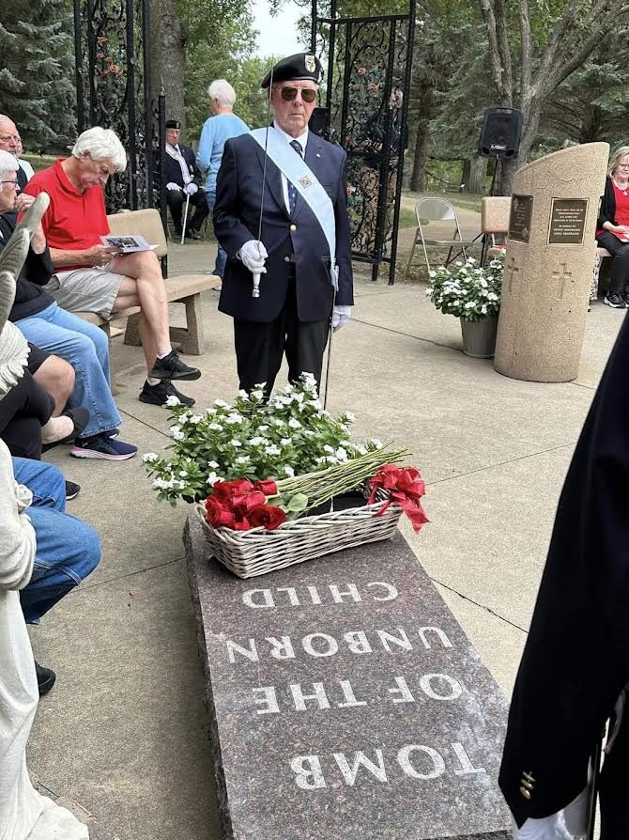
Memorial Service for Unborn Children at Trinity Heights

FAItHFUL PILOTS REPORT
September Honor Guards
9 September, 2023 Memorial to the unborn at Trinity Heights:
Marty Pasker, Jim Sanders, Michael Hays, Michael Peters
24 September2023 Confirmation at Sioux City Nativity Church
Ricardo Rocha, Jim Sanders, Michael Hays, Michael Peters, John Hildman
29 September2023 Blue Mass at Cathedral of The Epiphany:
Ricardo Rocha, Jim Sanders, Michael Hays, Michael Peters, John Hildman, Marty Pasker, John Staiert, Michael Koch
Color Guards Needed:
October 14, 22023 Confirmation Mass at St Mary’s , Hawarden, IA Be there 3:30 PM
November 5, 2023 Confirmation at Sioux City St Michaels Church. Be there at 1:30 PM
November 12, 2023 Memorial Mass at Sioux City St. Michael Church following 11:00 Mass

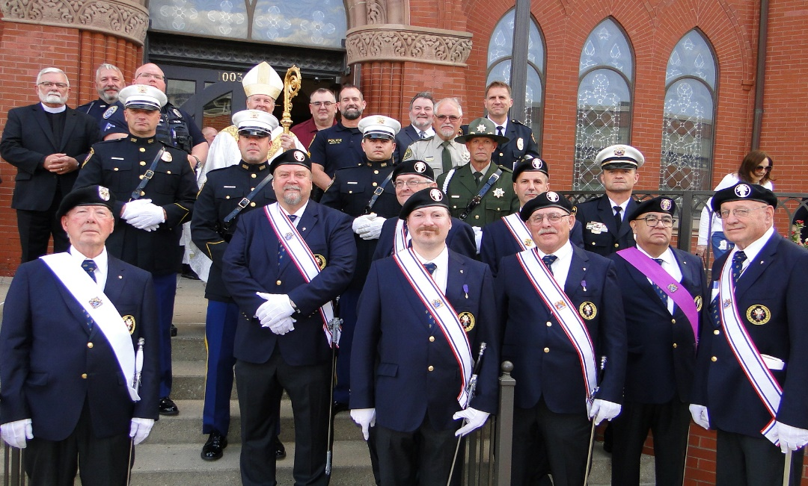.
Blue Mass At Cathedral of Epiphany September 29

