FAITHFULL FRIAR REPORT
There is only one God, but in Him, three distinct Persons: the Father, the Son, and the Holy spirit:
The Father is God, the Son is god, the Holy spirit is God. However , these three persons are not three Gods, but only one God. The Son is the Word, or the interior voice of the Father, and begotten by the Father alone; the Holy Spirit is the mutual Love of the Father and the Son, and He proceeds from both. The three Persons of the Blessed Trinity are all equal in all things because they have only one nature, the Divine Nature: in this consist the Mystery of the Holy Trinity.

Please keep the following in your prayers
Father Paul Albenesius, Father Dennis Meinen, Father Thomas Topf, Father Paul Bormann, Bishop R.Wallker Nickless, Sister Jean Marie, Doris Ott, Rick Davis, Mark Nixa, Sandy Bokemper, Gene Waag Sharon Seuntjens, Mike Boggs, Steve Cogdill Jr. Patricia LeClair, Marcia Goeden, Robert Goeden , Larry Kastrup, Valentin Magana, Ed Womack, Ann Womack, Julie Riedy, Jean Butler, Jack Garthright. Roxanne Winterfield, Tammy Pasker, Jerome Puhl , Bob Kenaley, Hilda Luna, Jim Coy, Dennis Todd, Ronald Lansink, Lyle Spieler, Larry Harrington, Jesse Padilla, Arden Gale, Manuel Luna, Bob Duncan, Francis Palmershiem, Doug Peters, Terri Mareau, John Voeltz, Gene Rolfes, Fred McPherson, Charles Myers, Chris Utesch,, Orlando Gill, Gary Engel, Don Roger, Denice Peters, Marilyn Laing, John Green, Robert Red Owl, Ricardo Rocha, Dennis Fredricksen, Clarice Wilken, Patricia Christensen, Persecuted Clergy and any others we may have missed.

PRAYER FOR THE SICK
Ever abiding on, the sick need you in their lives more than ever. Each day brings its own set of challenges for their vulnerable spirit and body. Help them to live with the conditions of their illness without giving in to discouragement or despair.
Do not let the conditions and the unknowns drown out the voice of your tender presence. Guide the physicians sto make good decisions. Give them the courage and wisdom to make their own good choices in treating this illness of theirs
Teach them to embrace the gift of each new day and to give thanks for those who help them through the ups and down of this process Constantly assure them that you will not forsake them. May you always be at their side, their trusted guardian. Help them to walk the delicate path of hope and surrender. Amen

Knights of Columbus Fourth Degree
Garrigan Assembly
PO Box 515
Sergeant Bluff, IA 51054
KC265Garrigan.weebly.com

September 2023

OFFICERS
Faithful Friar Rev. Dennis W. Meinen 712-258-9120
Faithful Navigator Jim Sanders 712-259-5399
Faithful Captain Michael Peters 712-259-6225
Faithful Pilot Ricardo Rocha 712-899-3700
Faithful Admiral Edward Womack 712-219-0374
Faithful Comptroller Randy Kramer 712-251-5100
Faithful Scribe Mark Fachman 712-333-2760
Faithful Purser John Staiert 712-898-9891
Faithful Inner Sentinel Michael Koch 712-574-9334
Faithful Outer Sentinel Michael Hays 605-740-6648
Faithful 1 yr. Trustee Stan Rolfes 712-568-3492
Faithful 2 yr. Trustee Marty Pasker 712-276-3672
Faithful 3yr. Trustee Donald Davis 712-216-0415
Faithful Chalice Society Ricardo Rocha 712-899-3700
Faithful Web Master Michael Peters 712-259-6225
UPCOMING MEETINGS

September 21, 2023 Regular Meeting at Hawarden St Mary’s Parish Hall
Social @ 6;15, Dinner @ 6:45 Meeting to follow
October 19, 2023 Regular Meeting at Sioux City Sacred Heart Parish Hall
Social @ 6;15, Dinner @ 6:45 Meeting to follow
16 November 2023 Regular meeting at Sioux City Cathedral Social at 6:15, dinner at 6:45 Meeting to follow

FAITHFUL NAVIGATORS REPORT

This newsletter is dedicated to the memory of Sir Knight Gerald G. Reinert, who passed away August 19, 2023. Jerry, as he was known to most, was an active Knight in many leadership roles throughout his over 50 years in the Knights of Columbus. I got to know Jerry when I became a 4th degree Knight in 2001. Jerry was very instrumental with the success of this newsletter. He often times wrote articles, prepared the letter for print and mailed it out. Shortly after I became your Faithful Navigator, Jerry’s health became a serious issue. One conversation I vividly remember was when he told me he just couldn’t address the envelopes anymore…”you’ll just have to fire me.” I replied, “I will never do that.” Jerry was scheduled to be honored at our recent Exemplification for new members entering the 4th degree. Our Savior had different plans for Jerry. Attached is a photo of the plaque to be presented to Jerry. It will instead be presented to his family. God Bless Sir Knight Gerald Reinert. Eternal rest Grant unto him O Lord, May he rest in Peace.

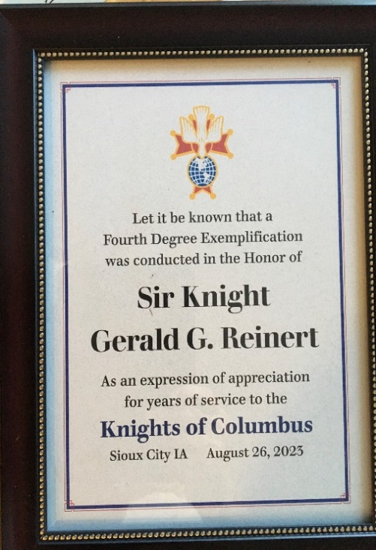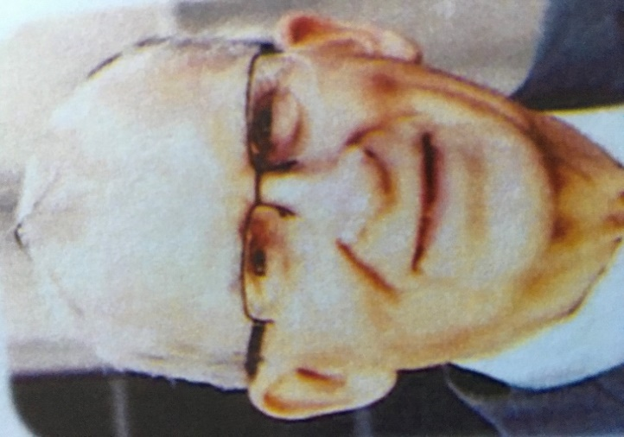

FAITHFUL PILOTS REPORT
August Honor Guards

3 August 20023 Flag Raising at Sioux City Explorers:
Jim Sanders, Michael Hays, Michael Gaspers, Michael Koch, Bob Duncan, Paul Roberts, Denny Kluver, Dennis Boyde, Irvin Oberreuter
5 August 2023 Deacon Ordination:
Michael Peters, Michael Hays, Michael Gaspers, Rick Boes (Carroll)
John Hildman, Ricardo Rocha, John Staiert, Jerry Collins,
Jim Sanders,
26 August, 2023 Fourth Degree Exemplification:
Michael Peters, Jim Sanders, Michael Hays, Ricardo Rocha,
Michael Koch, Jim Coy, Michael Gspers, John Staiert
28 August, 2023 Jerry Reinert Wake service:
Jim Sanders, Michael Hays, Jim Coy, Michael Koch, Ricardo Rocha, Michael Peters, Stan Rolfes
29 August, 2023 Jerry Reinert Funeral:
Jim Sanders, Michael Hays, Ricardo Rocha, Michael Koch

Color Guards Needed:

September 9 2023 Queen of Peace 2509 33rd St:
Memorial Service for the Unborn. Be there at 10:30 AM
October 1, 2023 Confirmation at Sioux City Nativity Parish. Be there 12:30 PM
October 19, 2023 Confirmation at Sioux City Nativity Parish. Be there at 12.30
November 5, 2023 Confirmation at Sioux City St Michaels Church. Be there at 1:30 PM

.

