FAITHFULL FRIAR REPORT

Prayer to Mary, Patroness to the United States
Most Holy Trinity, we put the United States of America into the hands of Mary Immaculate in order that she may present the country to you. Though you, we wish to thank you for the great resources of this land and for the freedom which has been its heritage.
Through the intercession of Mary, have mercy on the Catholic Church in America. Grant us peace. Have mercy on our president and on all of the officers of our government. Grant us a fruitful economy, born of justice and charity.
Have mercy on capital and industry and labor. Protect the family life of the nation. Guard the precious gift of many religious vocations. Through the intercession of our Mother, have mercy on the sick, the tempted, sinners, and all who are in need.
Mary, Immaculate Virgin, our Mother, Patroness of our land, we praise you and honor you and give ourselves to you. Protect us from every harm. Pray for us, that acting always according to your will and the will of your divine Son, we may live and die pleasing to God. Amen.
Please keep the following in your prayers
Father Paul Albenesius, Father Dennis Meinen, Father Thomas Topf, Father Paul Bormann, Bishop R.Wallker Nickless, Sister Jean Marie, Doris Ott, Rick Davis, Mark Nixa, Sandy Bokemper, Gene Waag Sharon Seuntjens, Mike Boggs, Barb Cogdill, Steve Cogdill Jr. Patricia LeClair, Marcia Goeden, Robert Goeden , Larry Kastrup, Valentin Magana, Ed Womack, Ann Womack, Julie Riedy, Jean Butler, Jack Garthright. Roxanne Winterfield, Jerry Reinert, Tammy Pasker, Jerome Puhl , Bob Kenaley, Hilda Luna, Jim Coy, Dennis Todd, Ronald Lansink, Lyle Spieler, Michael Peters, Larry Harrington, Jesse Padilla, Arden Gale, Manuel Luna, Bob Duncan, Francis Palmershiem, Doug Peters, Terri Mareau, John Voeltz, Gene Rolfes, Alvina Harvey, Fred McPherson, Charles Myers, Chris Utesch, Terrance Clarey, Orlando Gill, Gary Engel, Don Roger, Denice Peters, Marilyn Laing, Persecuted Clergy and any others we may have missed.

Prayer to God, The source of Health
God our Father, source of all health, be near those who suffer in time of weakness and pain: relieve them of their burden and heal them, if it be your will.
Give peaceful sleep to those who need rest for soul and body, and be with them in their hour of silence. Inspire with Your love those who bring healing and care to the suffering. May they bestow Your gift of health and strength wherever the go, Grant this prayer through Christ our Lord. Amen

Knights of Columbus Fourth Degree
Garrigan Assembly
525 S. Irene St.
Sioux City, IA 51106
KC265Garrigan.weebly.com

April 2023
OFFICERS
Faithful Friar Rev. Dennis W. Meinen 712-258-9120
Faithful Navigator Jim Sanders 712-259-5399
Faithful Captain Michael Peters 712-259-6225
Faithful Pilot Ricardo Rocha 712-899-3700
Faithful Admiral Edward Womack 712-219-0374
Faithful Comptroller Marty Pasker 712-276-3672
Faithful Scribe Mark Fachman 712-333-2760
Faithful Purser John Staiert 712-898-9891
Faithful Inner Sentinel David Butler 712-823-8687
Faithful Outer Sentinel Michael Hays 605-740-6648
Faithful 1 yr. Trustee Stan Rolfes 712-568-3492
Faithful 2 yr. Trustee Donnis Rogers 712-239 4529
Faithful 3yr. Trustee Donald Davis 712-216-0415
Faithful Chalice Society Ricardo Rocha 712-899-3700
Faithful Web Master Michael Peters 712-259-6225
UP COMING MEETINGS
April 20, 2023 St. John Parish Onawa, Iowa 1009 13th St
Social @ 6;15, Dinner @ 6:45 Meeting to follow
Car Pool at Sam’s Club at 5:00 PM
May 18, 2023 St. Joseph Parish Hall Salix, IA 510Tipton St
Social @ 6;15, Dinner @ 6:45 Meeting to follow
June 15, 2023 Sacred Heart Parish Hall Ida Grove, IA 800 N Main St. Social @ 6;15, Dinner @ 6:45 Meeting to follow

Faithful Navigator Comments
Almost 2000 years ago a simple man was wildly welcomed by throngs of common people hailing him as the one who would set them free from the harsh rule of a foreign despotic nation. It was not meant to be. For soon those throngs of people were influenced by their own religious leaders to openly reject and eventually celebrate his horrific death less than one week later.

His mission was not to free his nation from the bondage of a foreign nation. It was to offer the people comfort and peace through a loving, caring, forgiving God, his Father. Hence the birth of our Catholic faith. God, our Father through his son Jesus offers each of us forgiveness, unconditional love and peace. It is up to us to accept this gift or reject it. By accepting these gifts from Jesus, we are charged to share unconditionally them with others; so they also can experience the love of God through his son Jesus, too.

Prior to his Ascension into Heaven, Jesus charged his disciples to go forth onto all people and share these gifts He gave to us through his death on the cross. Let us continue this, my brother Sir Knights, for the betterment of all mankind.

Do you have a milestone coming up in your life (80th or 90th birthday, Wedding anniversary etc) let me know at 712-551-6943 or slr1964 @premieronline.net. I will try an enter it into the Newsletter if room is available.

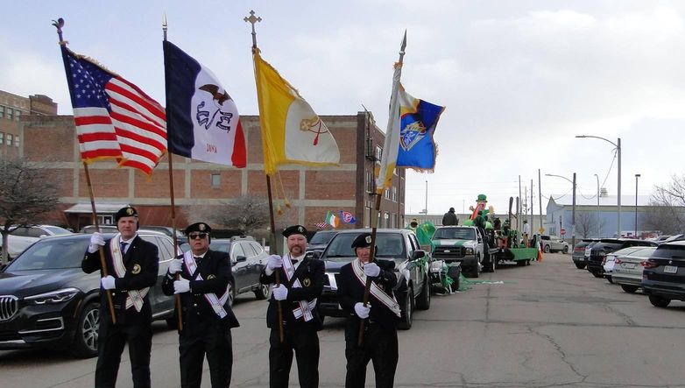

St. Patrick’[s Day Parade 2023

Faithful Pilots Report
17 March St Patrick’s Day Parade:
Ricardo Rocha, Jim Sanders, Michael Peters, John Hildman, Ron Haden, Michael Hays

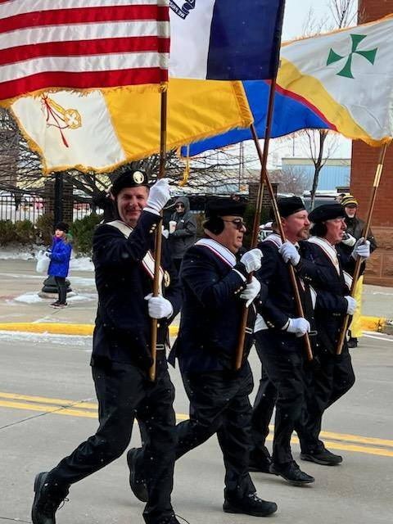

Color Guards Needed
April 16, 2023 Divine Mercy Sunday at St Michael’s Church 2222 Indian Hills Dr. Be there at 10:30 AM
16 May, 2023 Flag Raising at Sioux City Explorers
Be there at 6:30
29 May, 2023 Memorial Day Mass at Sioux City Calvary Cemetery
Be there 8:30
June 8, 2023 Flag Raising at Sioux City Explorers Baseball Game
Be there 6:30.

.

