FAITHFUL FRIAR REPORT
Prayer of Fortitude

Dear Jesus, lay your wounded Hand upon my weary head and teach me to have courage in the paths that I must tread. Bless me and bless those whom I love, and give grace to see these crosses bravely borne by us will keep us close to thee.
And if at times a shadow falls in unexpected ways, put Your gentle Hand in mine and guide me through the days. So bless my people, one and all with Thy protecting grace, and impart to them Thy wisdom ere they meet face to face.

Please keep the following in your prayers Father Paul Albenesius, Father Dennis Meinen, Father Thomas Topf, Father Paul Bormann, Sister Jean Marie, Doris Ott, Rick Davis, Mark Nixa, Sandy Bokemper, Gene Waag Sharon Seuntjens, Mike Boggs, Barb Cogdill, Steve Cogdill Jr. Patricia LeClair, Marcia Goeden, Robert Goeden , Larry Kastrup, Valentin Magana, Ed Womack, Ann Womack, Julie Riedy, Jean Butler, Jack Garthright. Roxanne Winterfield, Jerry Reinert, Tammy Pasker, Jerome Puhl , Bob Kenaley, Ruth Kenaley, Hilda Luna, Jim Coy, Dennis Todd, Ronald Lansink, Lyle Spieler, Michael Peters, Larry Harrington, Jesse Padilla, Arden Gale, Manuel Luna, Bob Duncan, Tom Huls, Francis Palmershiem, Terri Mareau, John Voeltz, Elizabeth McMillian, Mark Fachman, Persecuted Clergy and any others we may have missed.
Prayer to God, the source of Health

God our Father, source of all health, be near those who suffer in the time of weakness and pain; relieve them of their burden and heal them, if it be your will.
Give a peaceful sleep to those who need rest for soul and body, and be with them in their hours of silence. Bless those who know not what another day will bring.
Make them ready for whatever it may be. Whether they must stand, or sit or be confined, grant them a strong spirit.
Inspire with your love those who bring healing and care to those suffering. May they bestow Your gifts of health and strength wherever they go. Grant this prayer through Christ our Lord.

Knights of Columbus Fourth Degree
Garrigan Assembly
525 S. Irene St.
Sioux City, IA 51106
KC265Garrigan.weebly.com

August 2022

OFFICERS
Faithful Friar Rev. Dennis W. Meinen 712-258-9120
Faithful Navigator Jim Sanders 712-259-5399
Faithful Captain Michael Peters 712-259-6225
Faithful Pilot Ricardo Rocha 712-899-3700
Faithful Admiral Edward Womack 712-219-0374
Faithful Comptroller Marty Pasker 712-276-3672
Faithful Scribe Mark Fachman 712-333-2760
Faithful Purser John Staiert 712-898-9891
Faithful Inner Sentinel David Butler 712-823-8687
Faithful Outer Sentinel Michael Hays 701580-0475
Faithful 1 yr. Trustee Stan Rolfes 712-568-3492
Faithful 2 yr. Trustee Donnis Rogers 712-239 4529
Faithful 3yr. Trustee Donald Davis 712-216-0415
Faithful Chalice Society Ricardo Rocha 712-899-3700
Faithful Web Master Michael Peters 712-259-6225
UPCOMING MEETINGS

August 18, 2022 Regular Meeting at St Patrick’s parish Hall, Fourth and Mill St
Akron, IA. Social at 6:15, Dinner at 6:45 with meeting to follow.

September 15, 2022 Regular meeting at St Mary’s Parish Hall, Hawarden, IA
Social at 6:15, Dinner at 6:45 and meeting to follow

October meeting site to be determined: Watch for information in September Newsletter

Faithful Navigator Comments

Thank you all for the trust and confidence placed on me to lead Garrigan Assembly as your Faithful Navigator. I humbly request your thoughts and prayers as I lead our Assembly.

One of my first priorities will be to encourage you, my brother Knights to encourage and escort your spouse to join us at our monthly meetings. I have requested my wife to develop worthwhile presentations and programs for the spouses while we fellow Knights conduct our meetings.

Lastly, I request each of you to sponsor good 3rd degree Knights to elevate to the 4th degree Knighthood. We can only move forward in our patriotic duty to God, Family and Country when we encourage active membership in the 4th Degree.

Remember, we have a 4th Degree Exemplification in Le Mars on August 27.

Again, thank you for the honor to be your Faithful Navigator.

There were 17 members present at the meeting in July at Immaculate Conception in Sioux City.

If you have not paid your 2022 dues, please do so

Faithful Pilots Report
Honor Guards
14 August, 2022 Flag Raising at Sioux City Explorers Baseball Game:
Ricardo Rocha, Michael Koch, Jim Sanders, Michael Hays, Marty Pasker

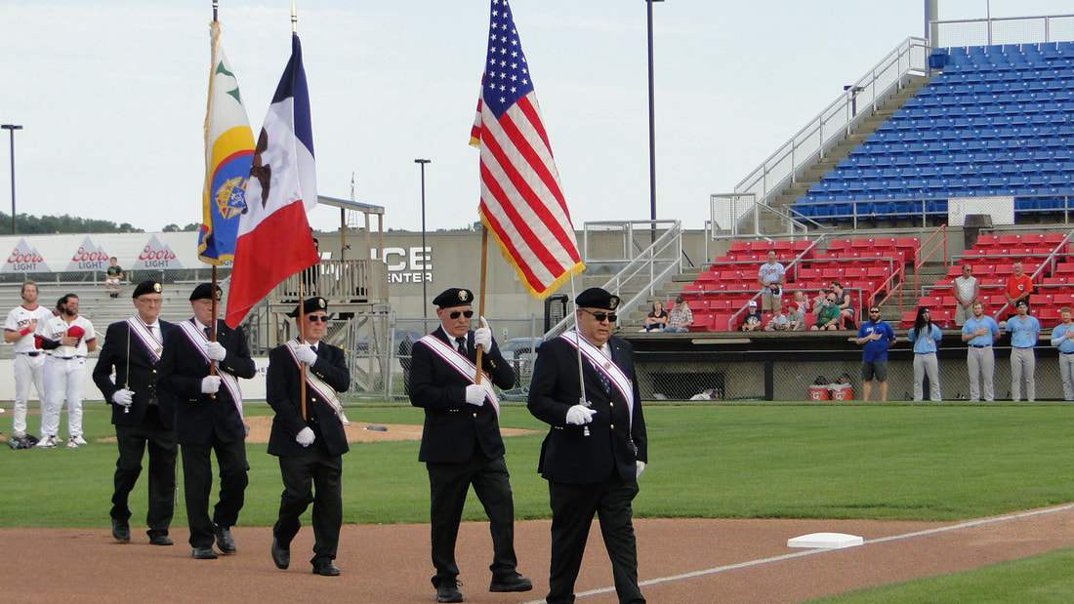

Honor Guards Needed:

27 August, 2022 4th Degree Exemplification in Le Mars

10 September 2022 Honor Guard at Trinity Heights Queen of Peace. Be there at 10:30

