FAITHFUL FRIAR REPORT
A CHRISTMAS TIME OF LOVE
Thank you Lord , for the loved ones I write to at this Blessed time, those, who have touched my life with their spirit. Grant me now in my happiness, a peace that , despite the distance, despite the maze of ministry, my love and fondness for them will never die.
We each have our unique way of relating to others, Lord, continue to empower everyone with the desire to welcome others to our family and assure them they will always belong, an always be remembered, even after God desires that they be with Him.
Give me a comfort that might not diminish the love that you my friends show me, the laughter that lifts me up and envelopes me and the tenderness that surrounds all you meet.
Oh Christ Child, smile at me from your manger. O beautiful mother Mary, help me to have your perfect love which casts out all fear. St. Joseph, defender of the defenseless, protect those who have left footprints on my heart.
Love me and help me reel your presence as you take up a pace deep in my heart with me
Please keep the following in your prayers Father Paul Albenesius, Father Dennis Meinen, Father Thomas Topf, Father Paul Bormann, Bishop R.Wallker Nickless, Sister Jean Marie, Doris Ott, Rick Davis, Mark Nixa, Sandy Bokemper, Gene Waag Sharon Seuntjens, Mike Boggs, Barb Cogdill, Steve Cogdill Jr. Patricia LeClair, Marcia Goeden, Robert Goeden , Larry Kastrup, Valentin Magana, Ed Womack, Ann Womack, Julie Riedy, Jean Butler, Jack Garthright. Roxanne Winterfield, Jerry Reinert, Tammy Pasker, Jerome Puhl , Bob Kenaley, Ruth Kenaley, Hilda Luna, Jim Coy, Dennis Todd, Ronald Lansink, Lyle Spieler, Michael Peters, Larry Harrington, Jesse Padilla, Arden Gale, Manuel Luna, Bob Duncan, Tom Huls, Francis Palmershiem, Doug Peters, Terri Mareau, John Voeltz, Mark Fachman, Gene Rolfes, Alvina Harvey, Fred McPherson, Charles Myers, Chris Utesch, Terrance Clarey, Orlando Gill, Gary Engel, Don Roger, Jim Henrich, Persecuted Clergy and any others we may have missed.
PRAYER FOR THE SICK
Ever abiding on, the sick need you in their lives more than ever. Each day brings its own set of challenges for their vulnerable spirit and body. Help them to live with the conditions of their illness without giving in to discouragement or despair.
Do not let the conditions and the unknowns drown out the voice of your tender presence. Guide the physicians to make good decisions. Give them the courage and wisdom to make their own good choices in treating this illness of theirs. Teach them to embrace the gift of each new day and to give thanks for those who help them through the ups and down of this process Constantly assure them that you will not forsake them. May you always be at their side their trusted guardian. Help them to walk the delicate path of hope and surrender. Amen

Knights of Columbus Fourth Degree
Garrigan Assembly
525 S. Irene St.
Sioux City, IA 51106
KC265Garrigan.weebly.com

December 2022
OFFICERS
Faithful Friar Rev. Dennis W. Meinen 712-258-9120
Faithful Navigator Jim Sanders 712-259-5399
Faithful Captain Michael Peters 712-259-6225
Faithful Pilot Ricardo Rocha 712-899-3700
Faithful Admiral Edward Womack 712-219-0374
Faithful Comptroller Marty Pasker 712-276-3672
Faithful Scribe Mark Fachman 712-333-2760
Faithful Purser John Staiert 712-898-9891
Faithful Inner Sentinel David Butler 712-823-8687
Faithful Outer Sentinel Michael Hays 701580-0475
Faithful 1 yr. Trustee Stan Rolfes 712-568-3492
Faithful 2 yr. Trustee Donnis Rogers 712-239 4529
Faithful 3yr. Trustee Donald Davis 712-216-0415
Faithful Chalice Society Ricardo Rocha 712-899-3700
Faithful Web Master Michael Peters 712-259-6225
UP COMING MEETINGS
December 15, 2022 Christmas Party at Grahms in Dakota Dunes
January 19, 2023 South Sioux City KC Hall
February 16, 2023 Sioux City St Michaels
March 16,2023 Mapleton
April 20, 2023 St. John Parish Onawa

Faithful Navigator Comments
Advent is upon us. Advent, a time to prepare us for the upcoming celebration of Jesus’ birth, gives us pause to place our lives in order. The Advent season allows and encourages us to allow God, our Father to help us prepare for His arrival in human form. The first week gives us hope for the present and future. The second week dwells upon peace. Third week (pink) pauses us to be joyful in the coming of our Lord. Finally, the forth week floods us with the feelings of love, a love from our Father that is all encompassing. Pray often Sir Knights during Advent. We have so much goodness awaiting us in the Spirit of Jesus’ birth.
Our December meeting is our Christmas dinner at Graham’s in North Sioux City, December 15th. The social hour starts at 5:30. Remember to call or text our Faithful Captain Michael Peters your reservation intent by December 10 for an accurate meal count. May our Lord bless you richly during this Advent season. I look forward to seeing as many of you as possible at our Christmas dinner. Yes, do bring your spouses. Dress is semi formal.

Progress update on the Eucharistic Miracles of the World project that the Garrigan Assembly has undertaken. We are going ahead with the printing of 52 Miracles banners and purchase of the stands. These banners will be stored at the radio station and the station will schedule the loan of these.
For councils and assemblies that donate to the cost of the banners, their identities will be listed on the banner cards with a cutoff date of November 1, 2022 for this section of banners. If your council would like to contribute to this project for the printing of more banners, please send your contribution to : John Staiert 2734 S. Cornelia St, Sioux City, IA 51106
Upcoming Events:.
December 15, 2022 Garrigan Assembly Christmas Party at Grahms in Dakota Dunes, SD. Social starts at 5:30
10 oz Prime Rib 22.98 Salmon or Top Sirloin at 18.98
Please let Michael Peters know of your intent to attend. (712-259-6225)

Faithful Pilots Report
HONOR GUARDS
2 Novmeber, 2022 Rudolph Daniels Wake Service: Michael Peters, Michael Hays, Jim Sanders, Steve Shults, John Staiert, David Butler, Marty Pasker, John Hillman, Roger Cramer.
3 November, 2022 Rudolph Daniels Funeral: Jim sanders, Michael Hays, David Butler, Marty Pasker, Steve Shults, Bernard Allousma, Roger Cramer.
20 November, 2022 Memorial Mass for Deceased Knights:Jim Sanders, Michael Peters, Marty Pasker, Michael Hays, David Butler
20 November , 2022 ConfirmationMass at Sioux City St Michaels
Jim Sanders, David Butler, Michael Hays, Michael Peters
21 November 2022 Christmas Parade in Sioux City:
Marty Pasker, Jim Sanders, Michael Kokch, Michael Peters, David Butler, Ricardo Rocha
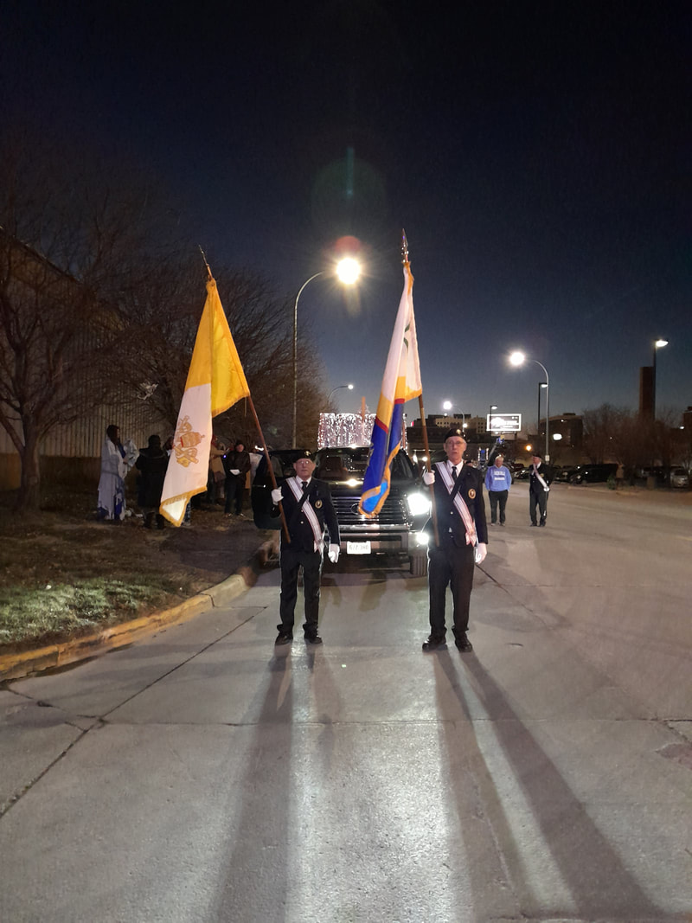

Holiday Lighting Parade in Sioux City

