FAITHFUL FRIAR’S REPORT
Lenten Season.
On February 14th, this year’s season of Lent begins. This is a special season in the life of the Church, and it is important to remind ourselves of the customs that we follow as Catholics during this season.
Ash Wednesday and Good Friday are both days of Fast and Abstinence. We are asked to have a full meal and two small ones. We are further asked to abstain from meat on those days.
We are also asked to abstain from taking meat on the Fridays of Lent. This helps us to focus on the truth of the journey to heaven and concentrate on the personal demands that Jesus preached.
We are also encouraged to take up an act of Penance. We ‘give up’ something during Lent to remind ourselves of the small disciplines that life in Christ demands.
The Church also reminds us of the obligation to go to confession between Ash Wednesday and Pentecost Sunday. Our parishes are so good at scheduling penance services to assist in this universal Catholic practice. May this year’s season of Lent bring us closer to God.
Fr. Francis.
Please keep the following in your prayers Father Paul Albenesius, Father Thomas Topf, Father Paul Bormann, Sister Jean Marie, Doris Ott, Rick Davis, Sandy Bokemper, Gene Waag Sharon Seuntjens, Mike Boggs, Steve Cogdill Jr. Patricia LeClair, Marcia Goeden, Robert Goeden , Larry Kastrup, Valentin Magana, Ed Womack, Ann Womack, Julie Riedy, Jean Butler, Jack Garthright. Roxanne Winterfield, Tammy Pasker, Jerome Puhl , Bob Kenaley, Jim Coy, Dennis Todd, Ronald Lansink, Lyle Spieler, Larry Harrington, Jesse Padilla, Arden Gale, Manuel Luna, Bob Duncan, Doug Peters, Terri Mareau, John Voeltz, Gene Rolfes, Fred McPherson, Charles Myers, Chris Utesch,, Orlando Gill, Gary Engel, Don Roger, Marilyn Laing, John Green, Robert Red Owl, Ricardo Rocha, Dennis Fredricksen, Terry Clarey, Marci Hoffman, James Geary Jr. Kevin Sopha, Persecuted Clergy and any others we may have missed.

Ever abiding on, the sick need you in their lives more than ever. Each day brings its own set of challenges for their vulnerable spirit and body. Help them to live with the conditions of their illness without giving in to discouragement or despair. Constantly assure them that you will not forsake them. May you always be at their side their trusted guardian. Help them to walk the delicate path of hope and surrender. Amen
Knights of Columbus Fourth Degree

Garrigan Assembly
PO Box 515
Sergeant Bluff, IA 51054
KC265Garrigan.weebly.com

February 2024
OFFICERS

Faithful Friar Rev. Francis Makawinja 712-320-0723
Faithful Navigator Jim Sanders 712-259-5399
Faithful Captain Michael Peters 712-259-6225
Faithful Pilot Ricardo Rocha 712-899-3700
Faithful Admiral Edward Womack 712-219-0374
Faithful Comptroller Randy Kramer 712-251-5100
Faithful Scribe Mark Fachman 712-333-2760
Faithful Purser John Staiert 712-898-9891
Faithful Inner Sentinel Michael Koch 712-574-9334
Faithful Outer Sentinel Michael Hays 712-710-8825
Faithful 1 yr. Trustee Stan Rolfes 712-568-3492
Faithful 2 yr. Trustee Marty Pasker 712-276-3672
Faithful 3yr. Trustee Donald Davis 712-216-0415
Faithful Chalice Society Ricardo Rocha 712-899-3700
Faithful Web Master Michael Peters 712-259-6225
UPCOMING MEETINGS

15 February, 2024 Regular Meeting at Sioux City St. Michael’s Parish Hall 2223 Indian Hills Dr. . Social at 6:15 Dinner at 6:45 Meeting to follow

21 March 2024 Regular Meeting at St Mary’s Parish Hall Mapleton, IA
Social at 6:15 Dinner at 6:45 Meeting to follow

18 April, 2024 Regular Meting St. John’s Parish Hall, Onawa, IA.
Social at 6:15 Dinner at 6:45 Meeting to follow

FAITHFUL NAVIGATOR’S REPORT

Are we preparing ourselves for the coming of Jesus during the upcoming Lenten season? Some of us may favor sacrifice, others choose good works or some a more penitential way to approach Lent. Fortunately we all have many resources in our Parishes to help us develop our involvement in Lent. Lent affords us the opportunity to rid our daily lives of the clutter that gets in the way of our relationship with Jesus. Whatever we do in our lives during the Lenten season, let us all allow the Holy Spirit to guide our way to a beneficial Lent for all.
An up coming event for our Assembly features the St. Patrick’s day parade March 17 in Sioux City. Hopefully the weather is more hospitable than last year. Our February meeting is at St. Michaels Catholic Church in Sioux City, February 15th. Let’s bring our spouses or a significant other to celebrate a post valentine dinner meeting.
Don’t forget your dues if you haven't already done so. Please return them plus your current/ temporary mailing address, best phone numbers and your email address. This is important so we can stay in contact with you throughout the year.
Lastly, may our Lord and Savior bless and guide each of us in our daily endeavors.

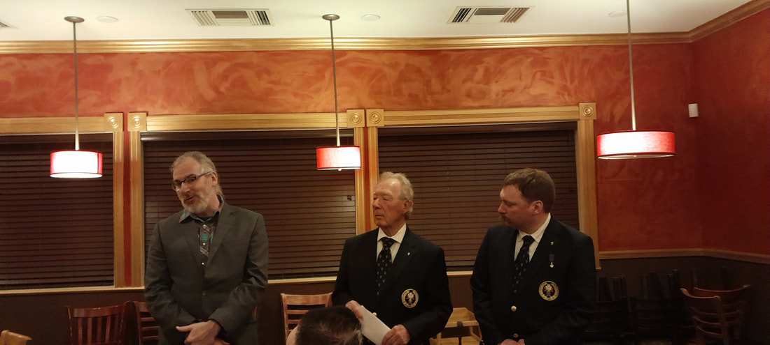

Donating the proceeds of the 50-50 raffle to F.I.R. E. of NW Iowa
at the Annual 4th Degree Christmas Party

FAITHFUL PILOT’S REPORT
23 January, 20244 Francis Palmershein Wake Service:
Michael Koch, Michael Hays, Michael Peters, Jim Sanders,
Ricardo Rocha
24 January, 2024 Francis Palmershein Funeral:
Ricardo Rocha, Michael Hays, David Butler

Up Coming Honor Guards Needed

17 March 2024 St Patrick’s Day Parade.
Meet at 2:00 pm at 3rd and Iowa St in Sioux City

7 April, 2024 Color Guard needed. More info to come

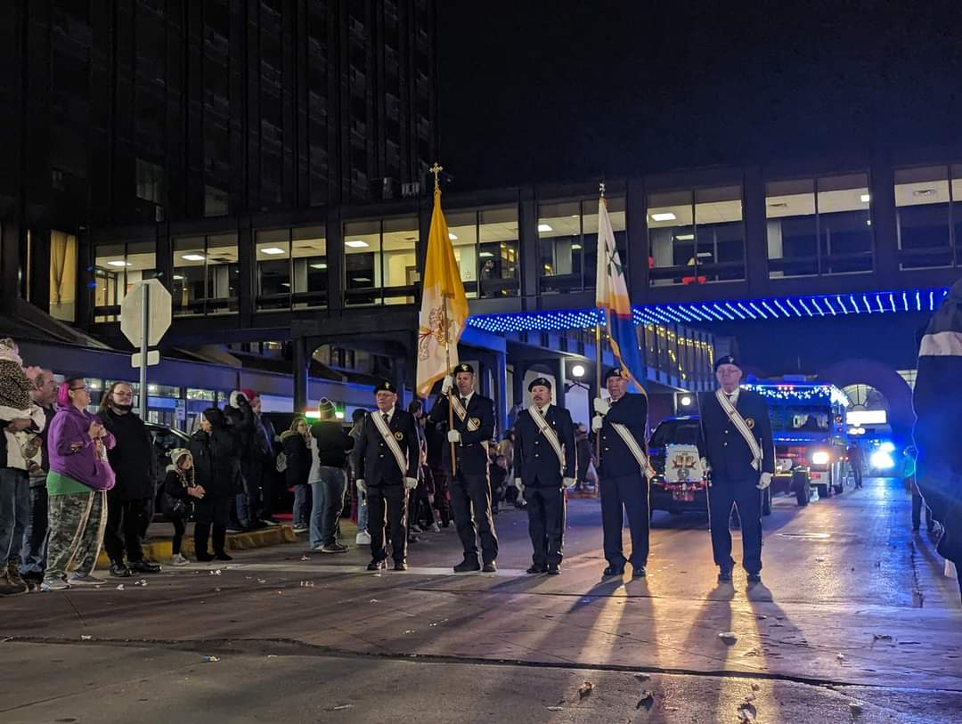

2023 Holiday Lighted Parade in downtown Sioux City, IA

