FAITHFUL FRIAR REPORT
New Year Blessing
Bless us O Lord, and bless the time and seasons yet to come. Teach us to number our days aright, that we may gain wisdom of heart and fill the new year with your kindness, that we may be glad and rejoice all the days of our life.
Loving God, giver of all gifts, we ask you to grant us openness to your call, that we maybe renewed in your spirit and united in love with one another. Help us to recognize our own giftedness that we may show these gifts for the good of all your people. We pray that we may truly reflect your love to all we meet Bless our efforts to live out the gospel message by deepening our faith in Jesus Christ, whose spirit enlivens us and refreshes us. Amen
Please keep the following in your prayers Father Paul Albenesius, Father Dennis Meinen, Father Thomas Topf, Father Paul Bormann, Bishop R.Wallker Nickless, Sister Jean Marie, Doris Ott, Rick Davis, Mark Nixa, Sandy Bokemper, Gene Waag Sharon Seuntjens, Mike Boggs, Barb Cogdill, Steve Cogdill Jr. Patricia LeClair, Marcia Goeden, Robert Goeden , Larry Kastrup, Valentin Magana, Ed Womack, Ann Womack, Julie Riedy, Jean Butler, Jack Garthright. Roxanne Winterfield, Jerry Reinert, Tammy Pasker, Jerome Puhl , Bob Kenaley, Ruth Kenaley, Hilda Luna, Jim Coy, Dennis Todd, Ronald Lansink, Lyle Spieler, Michael Peters, Larry Harrington, Jesse Padilla, Arden Gale, Manuel Luna, Bob Duncan, Tom Huls, Francis Palmershiem, Doug Peters, Terri Mareau, John Voeltz, Mark Fachman, Gene Rolfes, Alvina Harvey, Fred McPherson, Charles Myers, Chris Utesch, Terrance Clarey, Orlando Gill, Gary Engel, Don Roger, Jim Henrich, Persecuted Clergy and any others we may have missed.
PRAYER FOR THE SICK
Ever abiding on, the sick need you in their lives more than ever. Each day brings its own set of challenges for their vulnerable spirit and body. Help them to live with the conditions of their illness without giving in to discouragement or despair.
Do not let the conditions and the unknowns drown out the voice of your tender presence. Guide the physicians to make good decisions. Give them the courage and wisdom to make their own good choices in treating this illness of theirs. Teach them to embrace the gift of each new day and to give thanks for those who help them through the ups and down of this process Constantly assure them that you will not forsake them. May you always be at their side their trusted guardian. Help them to walk the delicate path of hope and surrender. Amen

Knights of Columbus Fourth Degree
Garrigan Assembly
525 S. Irene St.
Sioux City, IA 51106
KC265Garrigan.weebly.com

January 2023
OFFICERS
Faithful Friar Rev. Dennis W. Meinen 712-258-9120
Faithful Navigator Jim Sanders 712-259-5399
Faithful Captain Michael Peters 712-259-6225
Faithful Pilot Ricardo Rocha 712-899-3700
Faithful Admiral Edward Womack 712-219-0374
Faithful Comptroller Marty Pasker 712-276-3672
Faithful Scribe Mark Fachman 712-333-2760
Faithful Purser John Staiert 712-898-9891
Faithful Inner Sentinel David Butler 712-823-8687
Faithful Outer Sentinel Michael Hays 701580-0475
Faithful 1 yr. Trustee Stan Rolfes 712-568-3492
Faithful 2 yr. Trustee Donnis Rogers 712-239 4529
Faithful 3yr. Trustee Donald Davis 712-216-0415
Faithful Chalice Society Ricardo Rocha 712-899-3700
Faithful Web Master Michael Peters 712-259-6225
UP COMING MEETINGS
January 19, 2023 South Sioux City KC Hall
Social @ 6;15, Dinner @ 6:45 Meeting to follow
February 16, 2023 Sioux City St Michaels
Social @ 6;15, Dinner @ 6:45 Meeting to follow
March 16,2023 Mapleton
Social @ 6;15, Dinner @ 6:45 Meeting to follow
April 20, 2023 St. John Parish Onawa

Faithful Navigator Comments
Merry Christmas and a Happy New Year to my fellow Sir Knights. I hope all is well with you and your families. We have some exciting events ready to unfold in 2023. I encourage you to participate in the spirit of our Lord and Savior, Jesus.
First, we have our January meeting scheduled at the KC hall in South Sioux City. Let’s put January 19, 2023, on our calendar of events. We will be discussing current and proposed events for 2023 at this meeting. Our host Council is looking forward to serving us a delicious meal before our meeting. Don’t forget to bring your spouses. An activity is planned for them while we meet.
Second, our Eucharistic Miracles banners are ready for display in your respective parishes. Just contact the Sioux City Catholic radio station to reserve them for your parish use.
Next is our participation in the annual St. Patrick’s day parade in Sioux City in Mid March. Let’s consider a great turnout of Sir Knights for this event. After all, it is an event honoring a great Saint, who was very instrumental in introducing our Catholic faith to the Irish.
Finally, I wish and pray for a wonderful, blessed and joyful New Year to each of you and your families in 2023. May our Lord and Savior bless us abundantly as we move forward with our activities in His name.

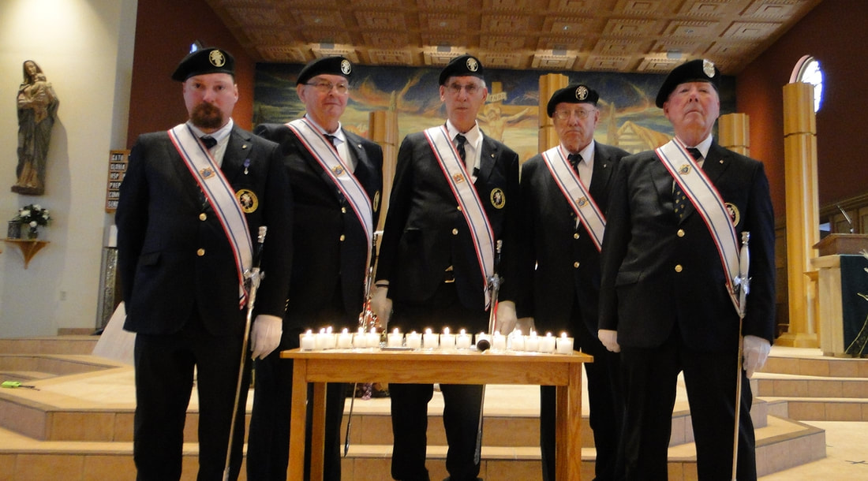
Memorial Mass in November

Faithful Pilots Report
12-5-2022 Confirmation Mater Dei Parish Sioux City:
Jim Sanders, Michael Peters, Roger Cramer, David Butler,
Michael Hays, Steve Shults, Michael Koch, Larry Locke,
Ricardo Rocha
12-11-2022 Patrick Engel Vigil Service:
Jim Sanders, Michael Peters, Don Rogers, David Butler, Michael Hays, Steve Shults, Michael Koch. Marty Pasker, John Staiert,
Jerry collins
12-12-2022 Patrick Engel Funeral Service:
Ricardo Rocha, David Butler, Michael Hays, Steve Shults,
Larry Locke

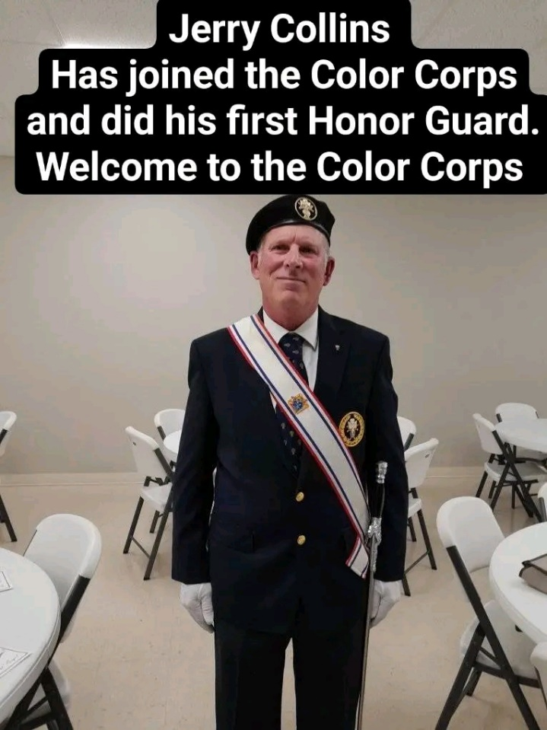
12/11/2022 IN SOUTH SIOUX CITY, NE

