FAITHFUL FRIARS REPORT
Having been tempted by the devil, our first parents disobeyed God. For this reason they lost for themselves snd for their posterity that life of grace and holiness. Adam transmitted that same disgrace and degradation to all his descendants, and this is the state of original sin to which we are all born. The gates of hell were closed to mankind as a result of original sin.
Only in Mary, in view of the merits od her Divine Son was exempt from original sin—from the first moment of her conception i.e .,from the moment hr soul was created and infused into her body it was free rom original sin and filled with sanctifying grace. This privilege is called the Immaculate Conception.
God had pity upon man whom he created with such love; and having subjected man from the time of Adam’s fall to sickness, ignorance, concupiscence and death, He promised a Redeemer who would make reparation for the sin of Adam and Eve and reopen the gates of heaven.
The human race never did completely forget this divine promise, although for many centuries before the coming of the Redeemer, it languished in the ways of corruption.
The hope for a Redeemer was kept alive among the Hebrew people, through the successive missions which God gave the Patriarchs, Moses and the Prophets. These extra ordinary men were not raised up for the sole purpose of reminding the Jews of their obligation to the moral law, but also to keep alive their hope to foretell the character and redeeming words of the future Messiah.
Please keep the following in your prayers Father Paul Albenesius, Father Thomas Topf, Father Paul Bormann, Sister Jean Marie, Doris Ott, Rick Davis, Sandy Bokemper, Gene Waag Sharon Seuntjens, Mike Boggs, Steve Cogdill Jr. Patricia LeClair, Marcia Goeden, Robert Goeden , Larry Kastrup, Valentin Magana, Ed Womack, Ann Womack, Julie Riedy, Jean Butler, Jack Garthright. Roxanne Winterfield, Tammy Pasker, Jerome Puhl , Bob Kenaley, Jim Coy, Dennis Todd, Ronald Lansink, Lyle Spieler, Larry Harrington, Jesse Padilla, Arden Gale, Manuel Luna, Bob Duncan, Francis Palmershiem, Doug Peters, Terri Mareau, John Voeltz, Gene Rolfes, Fred McPherson, Charles Myers, Chris Utesch,, Orlando Gill, Gary Engel, Don Roger, Marilyn Laing, John Green, Robert Red Owl, Ricardo Rocha, Dennis Fredricksen, Terry Clarey, Marci Hoffman, James Geary Jr. Kevin Sopha, Persecuted Clergy and any others we may have missed.

Ever abiding on, the sick need you in their lives more than ever. Each day brings its own set of challenges for their vulnerable spirit and body. Help them to live with the conditions of their illness without giving in to discouragement or despair. Constantly assure them that you will not forsake them. May you always be at their side their trusted guardian. Help them to walk the delicate path of hope and surrender. Amen

Knights of Columbus Fourth Degree
Garrigan Assembly
PO Box 515
Sergeant Bluff, IA 51054
KC265Garrigan.weebly.com

January 2024
OFFICERS
Faithful Friar Rev. Francis Makawinja 712-320-0723
Faithful Navigator Jim Sanders 712-259-5399
Faithful Captain Michael Peters 712-259-6225
Faithful Pilot Ricardo Rocha 712-899-3700
Faithful Admiral Edward Womack 712-219-0374
Faithful Comptroller Randy Kramer 712-251-5100
Faithful Scribe Mark Fachman 712-333-2760
Faithful Purser John Staiert 712-898-9891
Faithful Inner Sentinel Michael Koch 712-574-9334
Faithful Outer Sentinel Michael Hays 712-710-8825
Faithful 1 yr. Trustee Stan Rolfes 712-568-3492
Faithful 2 yr. Trustee Marty Pasker 712-276-3672
Faithful 3yr. Trustee Donald Davis 712-216-0415
Faithful Chalice Society Ricardo Rocha 712-899-3700
Faithful Web Master Michael Peters 712-259-6225
UPCOMING MEETINGS

18 January, 2024 Regular Meeting South Sioux City Knights of Columbus Hall 1805 W 29th St South Sioux City NE. Social at 6:15 Dinner at 6:45 Meeting to follow.

15 February, 2024 Regular Meeting at Sioux City St. Michael’s Parish Hall 2223 Indian Hills Dr. . Social at 6:15 Dinner at 6:45 Meeting to follow

21 March 2024 Regular Meeting at St Mary’s Parish Hall Mapleton, IA
Social at 6:15 Dinner at 6:45 Meeting to follow

FAITHFUL NAVIGATORS REPOR
The brightly colored Christmas wrap is mostly bagged and in a dumpster, while the gifts it wrapped is starting to loose some of its ardor. Yet the real gift we receive at Christmas continues to beam as bright as ever…the Gift itself, Jesus. Yes, this innocent baby born into a poor family became mankind’s most treasured gift for over 20 centuries. Let us not celebrate the gift of Christ in the few days before or after His birth, rather celebrate it as the greatest gift of all. He came into this world to save us from sin. May the true Spirit of Christmas remain in our hearts throughout each day of our lives.

This month our meeting is scheduled to be held at the Knights of Columbus hall in South Sioux City, January 18th. The social hour begins at 5:45pm with dinner following at 6:30pm. Our meeting will start at 7:30. Please bring your spouses, too.

May each of us celebrate the gift of Christ each day.

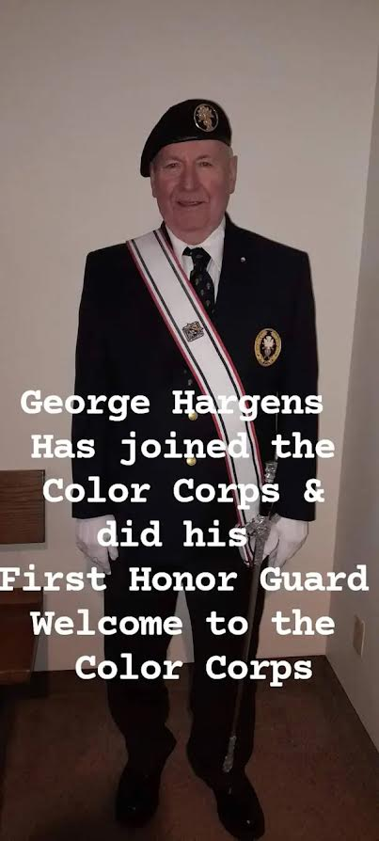
November 17, 2023 Honor Guard at Sioux City St Michael’s

FAITHFUL PILOT’S REPORT
No Honor Guards for December

Up Coming Honor Guards Needed

17 March 2024 St Patrick’s Day Parade.
Meet at 5:30 pm at 3rd and Iowa St in Sioux City

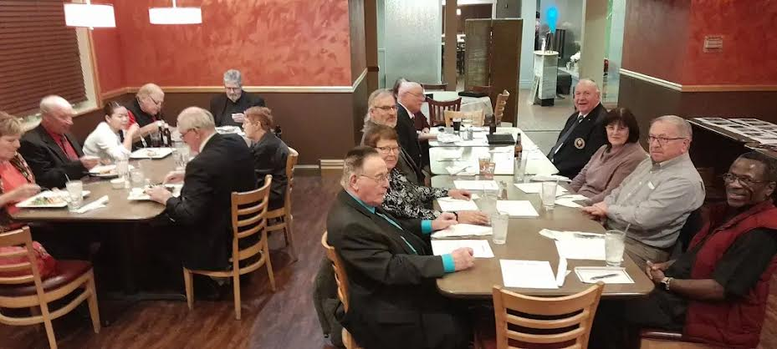December 7th, 2023 Christmas Party in Dakota Dunes, SD at Graham’s Grill& Pub

