FAITHFUL FRIAR REPORT

All Saints Day Prayer
Bless the many parted souls who lived their lives with grace. Bless the saints in heaven, gathered in that special place. May we tell their stories and remember all the ways
they lived their faith and spent their days.
There is glory and reward, even if at first there’s strife.
Oh, blessed saints, you help us see a path that’s to eternal life. May we always hold them dear and know their life and place. May we know their inspiration and aspire to their grace. Amen.
Please keep the following in your prayers Father Paul Albenesius, Father Dennis Meinen, Father Thomas Topf, Father Paul Bormann, Bishop R.Wallker Nickless, Sister Jean Marie, Doris Ott, Rick Davis, Mark Nixa, Sandy Bokemper, Gene Waag Sharon Seuntjens, Mike Boggs, Barb Cogdill, Steve Cogdill Jr. Patricia LeClair, Marcia Goeden, Robert Goeden , Larry Kastrup, Valentin Magana, Ed Womack, Ann Womack, Julie Riedy, Jean Butler, Jack Garthright. Roxanne Winterfield, Jerry Reinert, Tammy Pasker, Jerome Puhl , Bob Kenaley, Ruth Kenaley, Hilda Luna, Jim Coy, Dennis Todd, Ronald Lansink, Lyle Spieler, Michael Peters, Larry Harrington, Jesse Padilla, Arden Gale, Manuel Luna, Bob Duncan, Tom Huls, Francis Palmershiem, Doug Peters, Terri Mareau, John Voeltz, Mark Fachman, Gene Rolfes, Alvina Harvey, Fred McPherson, Charles Myers, Chris Utesch, Terrance Clarey, Persecuted Clergy and any others we may have missed.
PRAYER FOR THE SICK
Ever abiding on, the sick need you in their lives more than ever. Each day brings its own set of challenges for their vulnerable spirit and body. Help them to live with the conditions of their illness without giving in to discouragement or despair.
Do not let the conditions and the unknowns drown out the voice of your tender presence. Guide the physicians to make good decisions. Give them the courage and wisdom to make their own good choices in treating this illness of theirs. Teach them to embrace the gift of each new day and to give thanks for those who help them through the ups and down of this process Constantly assure them that you will not forsake them. May you always be at their side their trusted guardian. Help them to walk the delicate path of hope and surrender. Amen

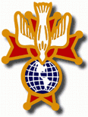
Knights of Columbus Fourth Degree
Garrigan Assembly
525 S. Irene St.
Sioux City, IA 51106
KC265Garrigan.weebly.com

November 2022

OFFICERS
Faithful Friar Rev. Dennis W. Meinen 712-258-9120
Faithful Navigator Jim Sanders 712-259-5399
Faithful Captain Michael Peters 712-259-6225
Faithful Pilot Ricardo Rocha 712-899-3700
Faithful Admiral Edward Womack 712-219-0374
Faithful Comptroller Marty Pasker 712-276-3672
Faithful Scribe Mark Fachman 712-333-2760
Faithful Purser John Staiert 712-898-9891
Faithful Inner Sentinel David Butler 712-823-8687
Faithful Outer Sentinel Michael Hays 701580-0475
Faithful 1 yr. Trustee Stan Rolfes 712-568-3492
Faithful 2 yr. Trustee Donnis Rogers 712-239 4529
Faithful 3yr. Trustee Donald Davis 712-216-0415
Faithful Chalice Society Ricardo Rocha 712-899-3700
Faithful Web Master Michael Peters 712-259-6225
UP COMING MEETINGS
November 17, 2022 Cathedral of Epiphany 1000 Douglas St, Sioux City, IA
Social at 6:15, Dinner at 6:45 Meeting to Follow
December 15, 2022 Christmas Party at Grahms in Dakota Dunes
January 19, 2023 South Sioux City KC Hall
February 16, 2023 Sioux City St Michaels
March 16,2023 Mapleton
April 20, 2023 St. John Parish Onawa

Faithful Navigator Comments
Sir Knights: Wow! Where did the time go? What a fast October it was. Fall dinners are in full swing. Do not forget to attend them. Also, volunteer for work when your parish dinner is scheduled. Thanks to those who donated their time and talent to those dinners.
Thank you Lord for your beam of wisdom and light for us in a world that at times is ready to collapse. Daily prayer to our Savior Jesus will get us through. That is the strength of our Fourth Degree of the Knights of Columbus. Let us never forget dedication to God, family and Country.
Lastly, let us not forget our fellow Knights who went before us, that showed us how to promote the goodness of our order. Remember our fallen Knights at our memorial service during and after the 10:00 Mass at Immaculate Conception Church in Sioux City November 20, 2022. I encourage all 4th degree Knights to attend this event and honor our Knights who left us in 2021-22. May God Bless their souls in Heaven.
Remember to bring your spouses for our meeting and dinner. While we have our meeting, there will be a program for our spouses. Please let our Faithful Captain (Michael Peters 712-259-6225) know by November 14 (Monday) of your intent to attend and if your spouse will attend either by phone or text. Our host KC council needs a meal count to prepare our dinner. May the Lord bless you all.
Progress update on the Eucharistic Miracles of the World project that the Garrigan Assembly has undertaken. We are going ahead with the printing of between 50 to 60 Miracles banners and purchase of the stands. These banners will be stored at the radio station and the station will schedule the loan of these.
For councils and assemblies that donate to the cost of the banners, their identities will be listed on the banner cards with a cutoff date of November 1, 2022 for this section of banners.
Upcoming Events:.
November 20, 2020 Memorial Mass at Sioux City Immaculate
Conception Church
November 20, 2020 Confirmation Mass at Sioux City St. Michaels 2223 Indian Hills Dr. Be there at 1:30
December 4, 2020 Confirmation Mass at Sioux City Nativity 4242 Natlia Way Be there at 12:30
December 15, 2022 Garrigan Assembly Christmas Party at Grahms Dakota Dunes, SD. Social starts at 5:30
10 oz Prime Rib 22.98 Salmon or Top Sirloin at 18.98

Faithful Pilots Report

HONOR GUARDS
8 October, 2022 Kurt Hodgins Memorial Service:
Ricardo Rocha, Marty Pasker, Michael Hays
9 October 2022 LeRoy Goeden Rosary and Burial:
Ricardo Rocha, Michael Koch, Marty Pasker, Michael Peters, David Butler, Michel Hays, John Staiert, Dennis Kluver
24 October, 2022 Confirmation Mass Sioux City Sacred Heart:
Ricardo Rocha, John Staiert, David Butler
24 October 2022 Father Cosgrove Visitation:
Jim Sanders, Michael Hays, Michel Koch, Michael Peters,
Marty Pasker,
25 October, 2022 Father Cosgrove Funeral:
Ricardo Rocha, Michael Hays, Michael Koch, David Butler,
Marty Pasker, Roger Kramer

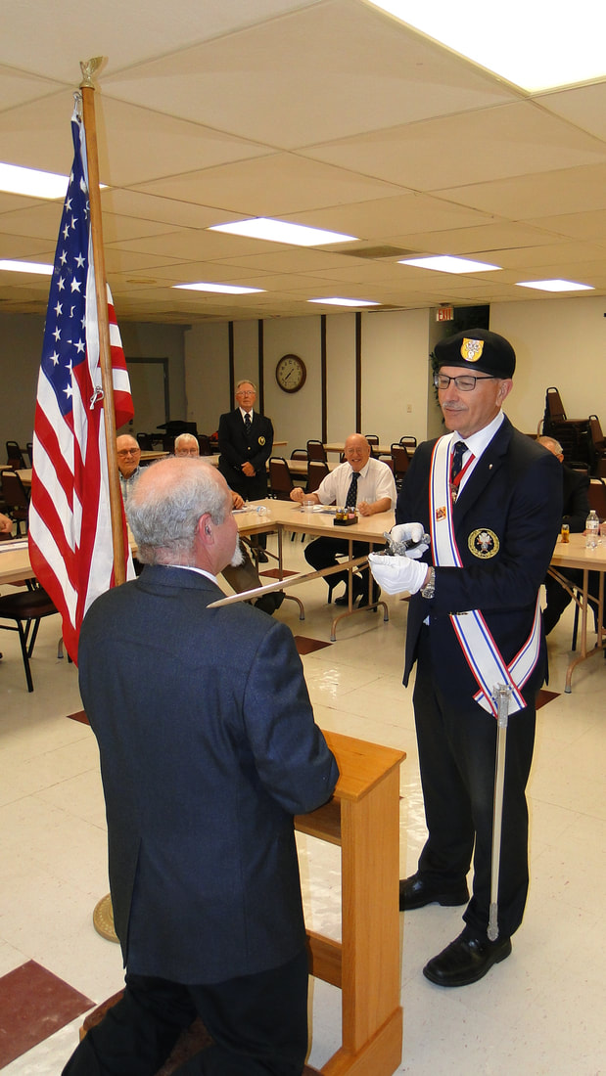
Knighting of a Sir Knight

