FAITHFULL FRIAR REPORT
God formed man and gave to him a living and immortal soul, created to His own image.
From Adam, the first man, and from Eve whom God gave to Adam as a companion, has sprung the whole human race.
God created us to know Him, to love Him, and to serve Him in this world and to be happy with Hime forever in Heaven.
God not only gave our first parents an immortal soul; He elevated them to a supernatural life of grace; He called them to enjoy His eternal happiness. In the first state of original injustice He exempted them from the ravages of sickness, ignorance, concupiscence, and death.

Please keep the following in your prayers
Father Paul Albenesius, Father Dennis Meinen, Father Thomas Topf, Father Paul Bormann, Bishop R.Wallker Nickless, Father David Hemann, Sister Jean Marie, Doris Ott, Rick Davis, Mark Nixa, Sandy Bokemper, Gene Waag Sharon Seuntjens, Mike Boggs, Steve Cogdill Jr. Patricia LeClair, Marcia Goeden, Robert Goeden , Larry Kastrup, Valentin Magana, Ed Womack, Ann Womack, Julie Riedy, Jean Butler, Jack Garthright. Roxanne Winterfield, Tammy Pasker, Jerome Puhl , Bob Kenaley, Hilda Luna, Jim Coy, Dennis Todd, Ronald Lansink, Lyle Spieler, Larry Harrington, Jesse Padilla, Arden Gale, Manuel Luna, Bob Duncan, Francis Palmershiem, Doug Peters, Terri Mareau, John Voeltz, Gene Rolfes, Fred McPherson, Charles Myers, Chris Utesch,, Orlando Gill, Gary Engel, Don Roger, Marilyn Laing, John Green, Robert Red Owl, Ricardo Rocha, Dennis Fredricksen, Clarice Wilken, Patricia Christensen, Terry Clarey, Marci Hoffman, James Geary Jr. Kevin Sopha, Persecuted Clergy and any others we may have missed.

Prayer to God, The source of Health
God our Father, source of all health, be near those who suffer in time of weakness and pain: relieve them of their burden and heal them, if it be your will.
Give peaceful sleep to those who need rest for soul and body, and be with them in their hour of silence. Inspire with Your love those who bring healing and care to the suffering. May they bestow Your gift of health and strength wherever the go, Grant this prayer through Christ our Lord. Amen

Knights of Columbus Fourth Degree
Garrigan Assembly
PO Box 515
Sergeant Bluff, IA 51054
KC265Garrigan.weebly.com

November 2023
OFFICERS
Faithful Friar Rev. Dennis W. Meinen 712-258-9120
Faithful Navigator Jim Sanders 712-259-5399
Faithful Captain Michael Peters 712-259-6225
Faithful Pilot Ricardo Rocha 712-899-3700
Faithful Admiral Edward Womack 712-219-0374
Faithful Comptroller Randy Kramer 712-251-5100
Faithful Scribe Mark Fachman 712-333-2760
Faithful Purser John Staiert 712-898-9891
Faithful Inner Sentinel Michael Koch 712-574-9334
Faithful Outer Sentinel Michael Hays 712-710-8825
Faithful 1 yr. Trustee Stan Rolfes 712-568-3492
Faithful 2 yr. Trustee Marty Pasker 712-276-3672
Faithful 3yr. Trustee Donald Davis 712-216-0415
Faithful Chalice Society Ricardo Rocha 712-899-3700
Faithful Web Master Michael Peters 712-259-6225
UPCOMING MEETINGS

16 November 2023 Regular meeting at Sioux City Cathedral Social at 6:15, dinner at 6:45 Meeting to follow
7 December, 2023 Annual Garrigan Assembly Christmas Party at Grahms in Dakkota Dunes Cocktails at 5:30 Dinner at 6:00 PM
18 January, 2024 Regular Meeting South Sioux City Knights of Columbus Hall 1805 W 29th St South Sioux City NE. Social at 6:15 Dinner at 6:45 Meeting to follow.

FAITHFUL NAVIGATORS REPORT

Holiday season greetings to my brother Sir Knights. Let us take time to reflect upon the seasons fast approaching, Thanksgiving, Advent and Christmas. Let us joyfully reflect upon the many gifts our Lord has given us this year.

We have several upcoming events in our Assembly. November 12th, following the 11 am Mass at St. Michaels Catholic Church in Sioux City, we will honor Sir Knights who passed away in the prior 12 months. November 20, we will have a float in the Sioux City downtown lighting parade. Weather permitting, I welcome all Sir Knights able, to participate in this parade, especially color corps members. Our annual Christmas dinner is scheduled December 7th at Graham’s in the Dunes at North Sioux City. Cocktails begin at 5:30 with dinner served at 6. During our dinner, we will present a check from 50/50 raffle proceeds to F.I.R.E., an area nonprofit agency. Please contact our Faithful Captain, Michael Peters to confirm your dinner reservation prior to December 1st.

Thanks to all of you for being dedicated Sir Knights of the Fourth Degree. May the Lord’s blessings be with you always.

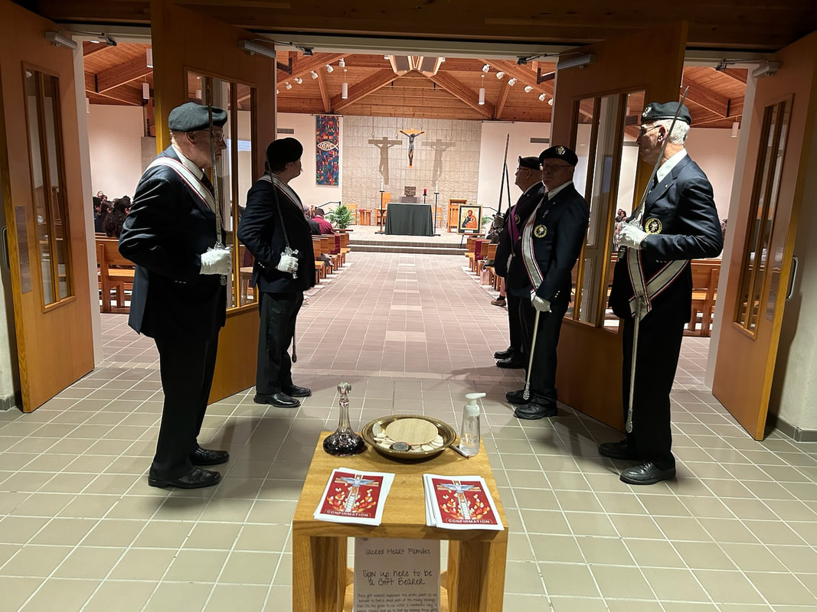
Confirmation at Sioux City Sacred Heart

FAITHFUL PILOTS REPORT
October Honor Guards
October 1, 2023 Confirmation at Sioux City Nativity Parish:
Ricardo Rocha, Jim Sanders, Michael Hays, Michael Peters,
John Staiert
October 5, 2023 White Mass at Sioux City Cathedral:
Jim Sanders, Michael Koch, Michael Hays, Michael Peters, Ricardo Rocha
October 14, 2023 Confirmation at St Mary’s Church, Hawarden, IA
Dave Larsen, Mark DeSutter, Curt Winterfeld, Stan Rolfes
October 23, 2023 Confirmation at Sioux City Sacred Heart:
Ricardo Rocha, Michael Koch, Michael Hays, Micheal Peters,
David Butler
Color Guards Needed:
November 12, 2023 Memorial Mass at Sioux City St. Michael Church following 11:00 Mass
November 19, 2023 Confirmation at Sioux City St Michael. Be there 1:30
November 20, 2023 Sioux City Downtown Lighting Parade:
Meet @ 4:30 3rd and Iowa St
