FAITHFUL FRIAR REPORT
Our Lord has also merited actual graces for us, those interior and supernatural helps given to us according to our needs in doing good and avoiding evil. The helps are of such necessity that without them it is impossible to elicit a good desire too have a good thought in the order of salvation. Jesus offered Himself for all human beings; His actual graces are given to all but not in the same measure because God is always the master of His gifts. Just as there is no one from whom the most powerful grace can take away free will, so also there is no one who can complain that the insufficiency of grace reduced him to the necessity of falling into sin. We have the sum total of graces sufficient for the acquisition of everlasting life, for which all of us have been created

Please keep the following in your prayers Father Paul Albenesius, Father Dennis Meinen, Father Thomas Topf, Father Paul Bormann, Bishop R.Wallker Nickless, Sister Jean Marie, Doris Ott, Rick Davis, Mark Nixa, Sandy Bokemper, Gene Waag Sharon Seuntjens, Mike Boggs, Barb Cogdill, Steve Cogdill Jr. Patricia LeClair, Marcia Goeden, Robert Goeden , Larry Kastrup, Valentin Magana, Ed Womack, Ann Womack, Julie Riedy, Jean Butler, Jack Garthright. Roxanne Winterfield, Jerry Reinert, Tammy Pasker, Jerome Puhl , Bob Kenaley, Ruth Kenaley, Hilda Luna, Jim Coy, Dennis Todd, Ronald Lansink, Lyle Spieler, Michael Peters, Larry Harrington, Jesse Padilla, Arden Gale, Manuel Luna, Bob Duncan, Tom Huls, Francis Palmershiem, Terri Mareau, John Voeltz, Mark Fachman, Gene Rolfes, Alvina Harvey, Fred McPherson, Charles Myers, Chris Utesch, Terrance Clarey, Persecuted Clergy and any others we may have missed.
Prayer to God, the source of Health God our Father, source of all health, be near those who suffer in the time of weakness and pain; relieve them of their burden and heal them, if it be your will. Give a peaceful sleep to those who need rest for soul and body, and be with them in their hours of silence. Bless those who know not what another day will bring. Make them ready for whatever it may be. Whether they must stand, or sit or be confined, grant them a strong spirit. Inspire with your love those who bring healing and care to those suffering. May they bestow Your gifts of health and strength wherever they go. Grant this prayer through Christ our Lord.

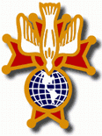
Knights of Columbus Fourth Degree
Garrigan Assembly
525 S. Irene St.
Sioux City, IA 51106
KC265Garrigan.weebly.com

October 2022

OFFICERS
Faithful Friar Rev. Dennis W. Meinen 712-258-9120
Faithful Navigator Jim Sanders 712-259-5399
Faithful Captain Michael Peters 712-259-6225
Faithful Pilot Ricardo Rocha 712-899-3700
Faithful Admiral Edward Womack 712-219-0374
Faithful Comptroller Marty Pasker 712-276-3672
Faithful Scribe Mark Fachman 712-333-2760
Faithful Purser John Staiert 712-898-9891
Faithful Inner Sentinel David Butler 712-823-8687
Faithful Outer Sentinel Michael Hays 701580-0475
Faithful 1 yr. Trustee Stan Rolfes 712-568-3492
Faithful 2 yr. Trustee Donnis Rogers 712-239 4529
Faithful 3yr. Trustee Donald Davis 712-216-0415
Faithful Chalice Society Ricardo Rocha 712-899-3700
Faithful Web Master Michael Peters 712-259-6225
UP COMING MEETINGS
October 20, 2022 Regular meeting at Sioux City Sacred Heart 5010 Military Road. Social 6:15 Dinner at 6:45 Meeting to follow
November 17, 2022 Cathedral of Epiphany 1000 Douglas St, Sioux City, IA
Social at 6:15, Dinner at 6:45 Meeting to Follow
December 15, 2022 Christmas Party at Grahms in Dakota Dunes
January 19, 2023 South Sioux City KC Hall
February 16, 2023 Sioux City St Michaels
March 16,2023 Mapleton
April 20, 2023 St. John Parish Onawa

Faithful Navigator Comments
Sir Knights:
What beautiful fall weather so far in Iowa. Recently my sister-in-law and I toured Queen of Peace. It had been years since I was last there. What a beautiful and peaceful setting it offered. It offers a quiet place to isolate and develop a great dialogue with our Lord and Savior, Jesus. The generosity and sacrifice people have made for us is truly a blessing. Thank you volunteers of all ages for allowing the Lord to create this beautiful area with your time, talents and sacrifice. Do not forget our meeting October 20th at Sacred Heart Catholic Church in Riverside of Sioux City. Remember to bring your spouses for our dinner. While we have our meeting, there will be a program for our spouses. Please let our Faithful Captain (Michael Peters 712-259-6225)know by October 17th (Monday) of your intent to attend and if your spouse will attend either by phone or text. Our host KC council needs a meal count to prepare our dinner. May the Lord bless you all.

There were 17 members present at Hawarden for the meeting.

Progress update on the Eucharistic Miracles of the World project that the Garrigan Assembly has undertaken. We are going ahead with the printing of between 60 – 70 Miracles banners and purchase of the stands. We are making the final selection of which Miracles will be printed (there are a total of 160+ with some being very similar we will choose a variety) and hope to be in print by the meeting date. The banners will be 24’ wide by 63” tall with the top half of each banner describing a Miracle and the bottom half of each one showing the logo of the Catholic Radio Station and the Knights of Columbus Garrigan Assembly as the sponsor. We are still working on support from all of the Councils in our Assembly for this first batch of Posters in hope other Councils and Assemblies in Northwest Iowa will notice and offer support.
Upcoming Events:.
November 20, 2020 Memorial Mass at Sioux City Immaculate
Conception Church
November 20, 2020 Confirmation Mass at Sioux City St. Michaels 2223 Indian Hills Dr. Be there at 1:30
December 4, 2020 Confirmation Mass at Sioux City Nativity 4242 Natlia Way Be there at 12:30
December 15, 2022 Garrigan Assembly Christmas Party at Grahms Dakota Dunes, SD. Social starts at 5:30
10 oz Prime Rib 22.98 Salmon or Top Sirloin at 18.98

Faithful Pilots Report

Honor Guards
9-10-2022 Trinity Heights: Michael Koch, David Butler

9-20-2022 Marvin Wycoff Funeral: Jim Sanders, Marty Pasker, Michael Gaspers

9-25 2022 Confirmation at Mater Dei Parish: Ricardo rocha, Michael Hays, Marty Pasker, David Butler, Jim Sanders, Michael Peters, MichaelKoch, Bernard Allssouma, John Staiert, John Hildaman

9-29-2022 Blue Mas at Cathedral of Epiphany: Ricardo Rocha, David Butler, Michael Hays, Marty Pasker, Jim Sanders

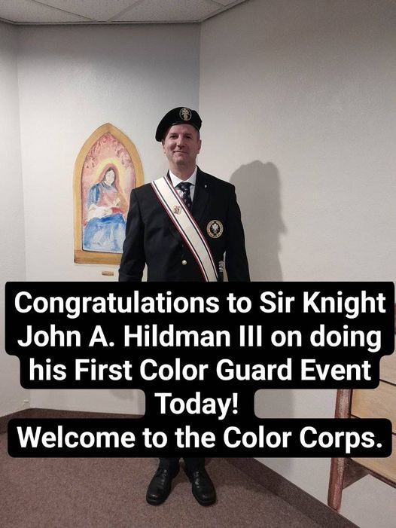

September 25th, 2022 Confirmation Mass at Nativity in Sioux City

